**PROJECT DOCUMENTATION**

# Deep Learning Fundus Image Analysis for Early Detection of Diabetic Retinopathy

**TEAM ID:-PNT2022TMID27696**

**Submitted By:-**

**TEAM LEADER**

**SRINIDHI M**

**TEAM MEMBERS**

**SOWMYA M**

**VARSHA H**

**VINDHIYA SRI U**

**Table of Contents:-**

###### INTRODUCTION

* 1. Project Overview
  2. Purpose

###### LITERATURE SURVEY

* 1. Existing problem
  2. References
  3. Problem Statement Definition

###### IDEATION & PROPOSED SOLUTION

* 1. Empathy Map Canvas
  2. Ideation & Brainstorming
  3. Proposed Solution
  4. Problem Solution fit

###### REQUIREMENT ANALYSIS

* 1. Functional requirement
  2. Non-Functional requirements

###### PROJECT DESIGN

* 1. Data Flow Diagrams
  2. Solution & Technical Architecture
  3. User Stories

###### PROJECT PLANNING & SCHEDULING

* 1. Sprint Planning & Estimation
  2. Sprint Delivery Schedule
  3. Reports from JIRA

###### CODING & SOLUTIONING (Explain the features added in the project along with code)

* 1. Feature 1
  2. Feature 2
  3. Database Schema (if Applicable)

###### TESTING

* 1. Test Cases
  2. User Acceptance Testing

###### RESULTS

* 1. Performance Metrics

###### ADVANTAGES & DISADVANTAGES

1. **CONCLUSION**

###### FUTURE SCOPE

1. **APPENDIX**

Source Code

GitHub & Project Demo Link

1. **INTRODUCTION :-**

The main causing of visual loss in the world is diabetic retinopathy. In the initial stages of this disease, the retinal microvasculature is affected by several abnormalities in the eye fundus such as the microaneurysms and/or dot hemorrhages, vascular hyper permeability signs, exudates, and capillary closures . Micro-aneurysm dynamics primarily increase the risk that the laser photo coagulation requires progression to the level . Diabetic retinopathy lesions are commonly accepted to be reversed and the progression of the retinopathy can only be slower during the early stages of the disease. The identification by repeated examination of patients affected of these initial lesions (mainly Micro aneurysms and small blood cells) is expected as a new possibility of improving retinopathy treatment. Floating and flashes, blurred vision, and loss of sudden vision can be common symptoms of diabetic retinopathy .

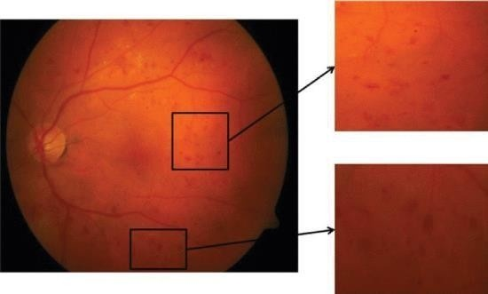

## Project Overview :-

Diabetic Retinopathy (DR) is a common complication of diabetes mellitus, which causes lesions on the retina that affect vision. If it is not detected early, it can lead to blindness. Unfortunately, DR is not a reversible process, and treatment only sustains vision. DR early detection and treatment can significantly reduce the risk of vision loss. The manual diagnosis process of DR retina fundus images by ophthalmologists is time, effort and cost-consuming and prone to misdiagnosis unlike computer-aided diagnosis systems.

Transfer learning has become one of the most common techniques that has achieved better performance in many areas, especially in medical image analysis and classification. We used Transfer Learning techniques like Inception V3,Resnet50,Xception V3 that are more widely used as a transfer learning method in medical image analysis and they are highly effective.

## Purpose :-

The Proposed work intends to automate the detection and classification of diabetic

isusedforclassification.Hyper-parameterslikenumberofconvolutionandpoolinglayer,number

convolutionandpoolinglayerused forfeatureextraction.Finallysupport vectormachine(SVM)

usedforclassificationofdiabeticretinopathy.The proposed CNNmodelconsistsof aseriesof

techniqueisproposedtoautomaticallydeterminetheparametersof CNNandthenthenetworkis

problembutthearchitectureofCNNismanuallydesigned.Inthiswork,ageneticalgorithmbased

classificationpurpose.Recentlyconvolutionalneuralnetwork(CNN)isusedforthisclassification

existingmethodsusehandcraftedfeaturesandthosearefedtotheclassifier fordetectionand

retinopathyfromretinal fundusimagewhich isveryimportant inophthalmology.Most ofthe

of kernel and kernel size of convolution layer are determined by using the genetic algorithm. The proposed methodology is tested on publicly available Messidor dataset. The proposed method has achieved accuracy of 0.9867 and AUC of 0.9933. Experimental result shows that proposed auto- tuned CNN performs significantly better than the existing methods. Use of CNN takes away the burden of designing the image features and on the other hand genetic algorithm based methodology automates the design of CNN hyper-parameters.

## LITERATURE SURVEY :-

###### ABSTRACT

**EXISITING PROBLEM:-**

Diabetic Retinopathy (DR) is a degenerative disease that impacts the eyes and is a consequence of Diabetes mellitus, where high blood glucose levels induce lesions on the eye retina. Diabetic Retinopathy is regarded as the leading cause of blindness for diabetic patients, especially the working-age population in developing nations. Treatment involves sustaining the patient’s current grade of vision since the disease is irreversible. Early detection of Diabetic Retinopathy is crucial in order to sustain the patient’s vision effectively. The main issue involved with DR detection is that the manual diagnosis process is very time, money, and effort consuming and involves an ophthalmologist’s examination of eye retinal fundus images. The latter also proves to be more difficult, particularly in the early stages of the disease when disease features are less prominent in the images. Machine learning-based medical image analysis has proven competency in assessing retinal fundus images, and the utilization of deep learning algorithms has aided the early diagnosis of Diabetic Retinopathy (DR). This paper reviews and analyzes state-of-the-art deep learning methods in supervised, self-supervised, and Vision Transformer setups, proposing retinal fundus image classification and detection. For instance, referable, nonreferable, and proliferative classifications of Diabetic Retinopathy are reviewed and summarized. Moreover, the paper discusses the available retinal fundus datasets for Diabetic Retinopathy that are used for tasks such as detection, classification, and segmentation. The paper also assesses research gaps in the area of DR detection/classification and addresses various challenges that need further study and investigation.

## REFERENCES:-

**DEEP LEARNING FUNDUS IMAGE ANALYSIS FOR EARLY**

**DETECTION OF DIABETIC RETINOPATHY**

**TEAM ID: PNT2022TMID27696**

**LITERATURE SURVEY**

| **S.NO** | **PAPER** | **AUTHOR** | **YEAR** | **METHOD AND ALGORITHM** | **ACCURACY** |
| --- | --- | --- | --- | --- | --- |
| 1. | Deep learning algorithms for detection of diabetic retinopathy in retinal fundus photographs: A systematic review and meta-analysis | Md Mohaimenul Islam, Hsuan-Chia Yang, Tahmina Nasrin Poly, Wen-Shan Jian, Yu-Chuan | 2020 | A systematic review with a meta-analysis of relevant studies was performed to quantify the performance of DL algorithms to detect DR. The findings of their study showed that DL-algorithms had high sensitivity and specificity for detecting referable DR from retinal fundus photographs. | 97% |
| 2. | Diabetic Retinopathy Diagnosis Through Computer-Aided Fundus Image Analysis | Jaskirat Kaur, Deepti Mittal & Ruchi Singla | 2021 | Computer-aided diagnostic assistance to an expert plays a vital part by aiding in the daily tasks of diagnosis of DR. As a result, numerous methods, such as morphology and thresholding, filtering, supervised methods, hybrid methods are being used to design such systems for the qualitative examination of retinal fundus images | 97.38% |
| 3. | Deep Learning Techniques for Diabetic Retinopathy Classification | Mohammad Z. Atwany, Abdulwahab H. Sahyoun, Mohammad Yaqub | 2022 | Diabetic Retinopathy classification can be categorized to either binary classification which aims to detect the presence or absence of DR and multi-class classification, which determines the exact stage of DR. Consequently, Supervised, Self-supervised, and Transformer methods were developed to focus on lesion-based classification. | 96.3% |
| 4. | Design an Early Detection and Classification for Diabetic Retinopathy by Deep Feature Extraction based Convolution Neural Network | Akey Sungheetha Kumarasuvamy, Rajesh Sharma Rajendran | 2021 | They proposed research work extracts the features by incorporating deep networks through convolution neural networks (CNN). The micro aneurysm may be seen in the early stages of the transformation from normal to sick condition on the images for mild DR. The level of severity of the diabetes condition may be classified by using the confusion matrix detection results. | 95.95% |
| 5. | Deep learning architecture based on segmented fundus image features for classification of diabetic retinopathy | Sraddha Das, Krity Kharbanda, Suchetha M, Rajiv Raman, Edwin Dhas D | 2021 | They have used a convolution neural network (CNN) to train the classifier for performing classification. The CNN, constructed for classification, comprises a combination of squeeze and excitation and bottleneck layers, one for each class, and a convolution and pooling layer architecture for classification between the two classes. For the performance evaluation of the proposed algorithm, They use the dataset DIARETDB1, comprised of fundus scans of both affected and normal retinas. | 98.7% |
| 6. | Diagnostic assessment of deep learning algorithms for diabetic retinopathy screening | Tao Li, Yingqi Gao, Kai Wang, Song Guo, Hanruo Liu, Hong Kang | 2019 | They collected 13,673 fundus images from 9598 patients. These images were divided into six classes by seven graders according to image quality and DR level. Moreover, 757 images with DR were selected to annotate four types of DR-related lesions. Finally, we evaluated state-of-the-art deep learning algorithms on collected images, including image classification, semantic segmentation and object detection. | 82% |

## 2.3.PROBLEM STATEMENT DEFINITION:-

problem statement is a concise description of an issue to be addressed or a condition to be improved upon. It identifies the gap between the cur rent state and desired state of a process or product. Focusing on the facts, the problem statement should be designed to address the Five Ws.

**OBJECTIVES** :

has arose as one of the most popular techniques that has enhanced performance in many areas The primary goal is to identify diabetic retinopathy by processing retinal images. Transfer learning, notably in the analysis and classification of medical images. We used transfer learning techniques that are more frequently used in medical image analysis and have been extremely effective, including such Inception V3, Resnet50, and Xception V3.

**IDEATION PHASE & PROPOSED SOLUTION :**

# 

# 2.1 Empathy Map Canvas :

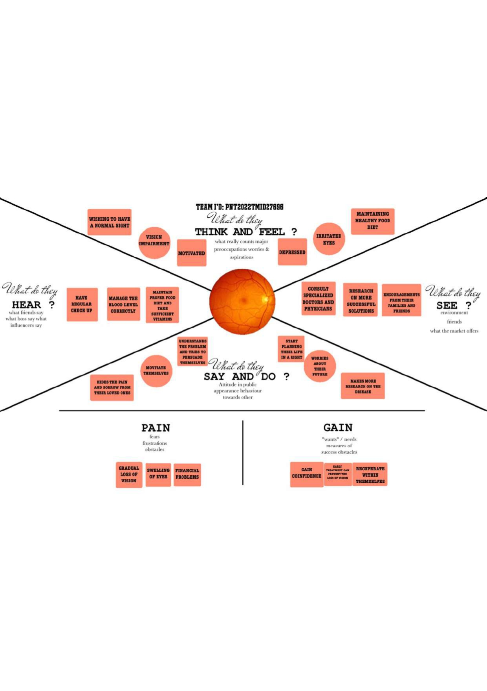

## IDEATION AND BRAINSTORMING:-

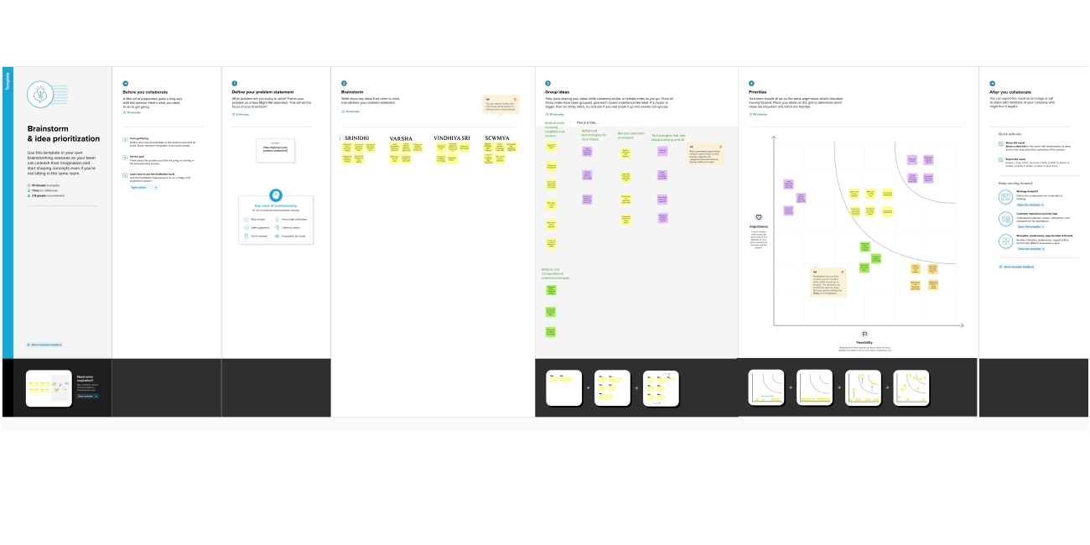

**2.3 PROPOSED SOLUTION:-**

|  |  |  |
| --- | --- | --- |
| **S.No.** | **Parameter** | **Description** |
| 1. | Problem Statement (Problem to be solved) | Diabetic Retinopathy(DR) is a common complicationof diabetes mellitus, which causes lesions on the retina that effect vision .if it is not detected early,it can lead to blindness.Developement on larger and more diverse datasets,such an algorithm could enable early datasets,such an algorithm could enable earlydiagnosis and referrel to a retina specialist for more frequent monitoring and even consideration of early intervention.Moreover,it could also improve patient recruitment for clinical trials targeting DR |
|  |
|  |
|  |
|  |
|  |
|  |
|  |
|  |
| 2. | Idea / Solution description | Many Artificial-Intelligence-powered methods have been proposed by the research community for the detection and classification of diabetic retinopathy on fundus retina images. |
| 3. | Novelty / Uniqueness | This work considers a deep learning methodology specifically a Convolutional Neural Network(CNN), which is applied for the early detection of diabetic retinopathy. |
| 4. | Social Impact / Customer Satisfaction | Regular dilated eye examinations are an effective approach to detecting and treating vision-threatening diabetic retinopathy. They can help prevent blindness, and they are cost-effective. This application satisfying their requirements without spending any cost. |
| 5. | Business Model (Revenue Model) | This can be converted as a bussiness model because it helps to prevent blindness of affected patient. Most of the common people and the hospitals will use this application. |
| 6. | Scalability of the Solution | This application will be scalable. Once the image is classified under the five category of diabetic retinopathy then the suitable diagnosis and the health tips(integrated with their daily life style) will be displayed. |

## 

## 2.4 PROPOSED SOLUTION FIT

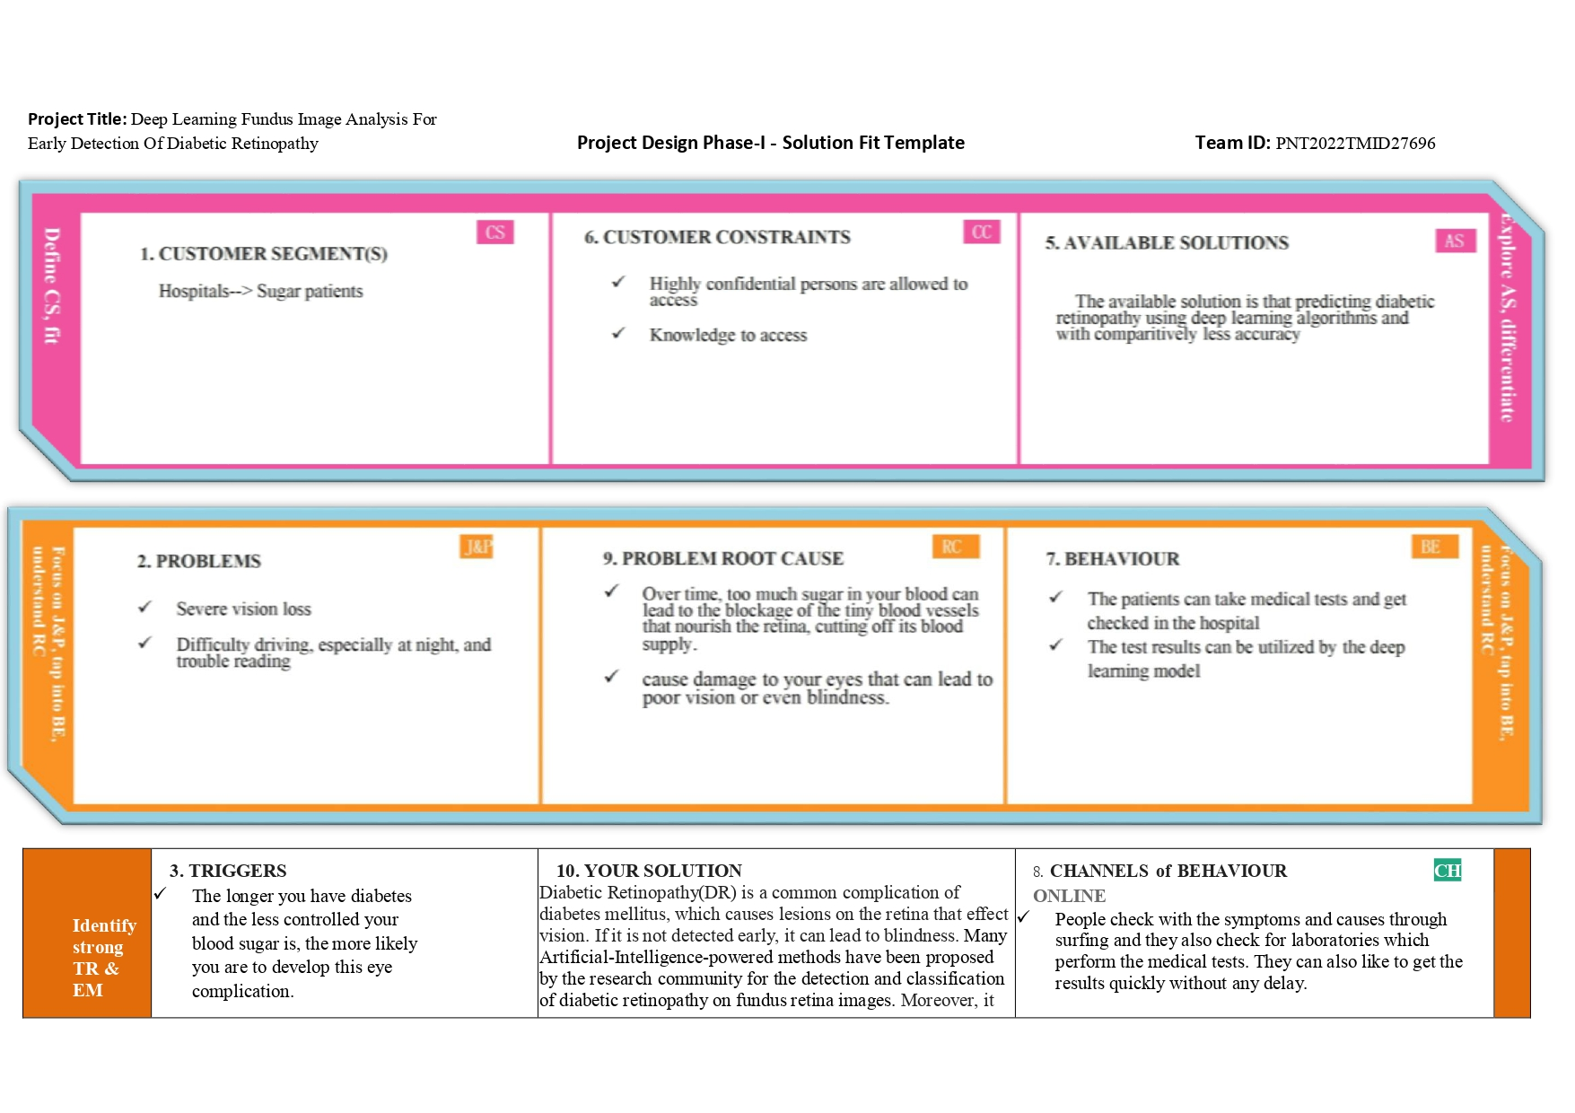

## 

## 2.5 FUNCTIONAL AND NON FUNCTIONAL REQUIREMENTS:-

**FUNCTIONAL REQUIREMENTS:**

Following are the functional requirements of the proposed solution.

|  |  |  |
| --- | --- | --- |
| **FR No.** | **Functional Requirement (Epic)** | **Sub Requirement (Story / Sub-Task)** |
| FR-1 | Identifying the population eligible for screening | Use registries to ensure that people's details are collected  and current, and decide which group needs to be tested based on the best available evidence. |
| FR-2 | Invitation and information | Invite the entire cohort to the screening, and provide information that is appropriate for each group.  To facilitate participation with knowledge |
| FR-3 | Testing | Conduct screening test(s) using agreed/recommended Methods |
| FR-4 | Referral of screen positives and reporting of screen-negative results | Send all positive findings from the screen to the appropriate services.additionally, ensure that screen  negatives are communicated to People who continue to participate in the screening program |
| FR-5 | Diagnosis | Diagnose true cases and identify false positives |
| FR-6 | Treatment | Correctly intervene and treat situations; in some  circumstances, surveillance or follow-up may also be necessary |
| FR-7 | Outcomes | Identify false negatives and increase the performance  and cost-efficiency of the screening program by gathering, analyzing, and reporting results. |

**NON FUNCTIONAL REQUIREMENTS:**

Following are the non-functional requirements of the proposed solution.

|  |  |  |
| --- | --- | --- |
| **FR No.** | **Non-Functional Requirement** | **Description** |
| NFR-1 | **Usability** | New findings for five distinct screening and clinical grading systems for diabetic retinopathy are presented. incorporating cutting-edge outcomes for  precisely identifying photographs based on clinical five-grade diabetic retinopathy |
| NFR-2 | **Security** | AI-powered deep learning can increase precision around delicate organs and tissues, minimize blood |

|  |  |  |
| --- | --- | --- |
|  |  | loss, infection risk, and discomfort during detection and screening. |
| NFR-3 | **Reliability** | Deep Learning's capability to do pattern recognition by building complex associations based on input data  and comparing them to performance standards is a significant advancement. |
| NFR-4 | **Performance** | Simply said, AI is the ability to complete a task. primarily performed by a robot or computer, with the involvement of people. common templates  for illustrating retinal findings that could be improved accuracy of results recorded. |
| NFR-5 | **Availability** | Health care affordability, quality, and accessibility Can be amplified using this technology. |
| NFR-6 | **Scalability** | In order to make high-quality systematic diabetic retinopathy screening a universal Offer to all persons with diabetes, it is possible to expand on existing  systems and use a stepwise approach to enhancing the efficacy of present techniques. |

## PROJECT DESIGN:-

* 1. **DATA FLOW DIAGRAM:-**

###### Data Flow Diagrams:

|  |  |
| --- | --- |
| Date | 10 October 2022 |
| Team ID | PNT2022TMID27696 |
| Project Name | Project - Deep Learning Fundus Image  Analysis For Early Detection Of Diabetic Retinopathy |
| Maximum Marks | 4 Marks |

The classic visual representation of how information moves through a system is a data flow diagram (DFD). The ideal amount of the system needs can be graphically represented by a tidy and understandable DFD. It demonstrates how information enters and exits the system, whatmodifies the data, and where information is kept.

* + - Diabetic retinopathy diseaseis frequently detected and examined using retinal fundus Pre-processing of raw retinal fundus images isperformed using extraction of the green channel, histogramequalization, image enhancement,and resizing techniques.
    - One of the main tasks in retinalimage processing is thesegmentation of the retinal vasculature from images of the eye fundus.
    - By omitting the optic disc (OD) regionof the retina, the computer-assisted automatic recognition and segmentation of blood vessels.
    - Mathematicalbinary morphological techniques are used to identify the retinal bloodvessels.
    - The term "feature extraction from the fundus images for the diagnosis of Diabetic Retinopathy" refers to a sophisticated eye screeningtechnique that allows for the early detection of eye-related disorders.

## TECHNOLOGY ARCHITECTURE:-

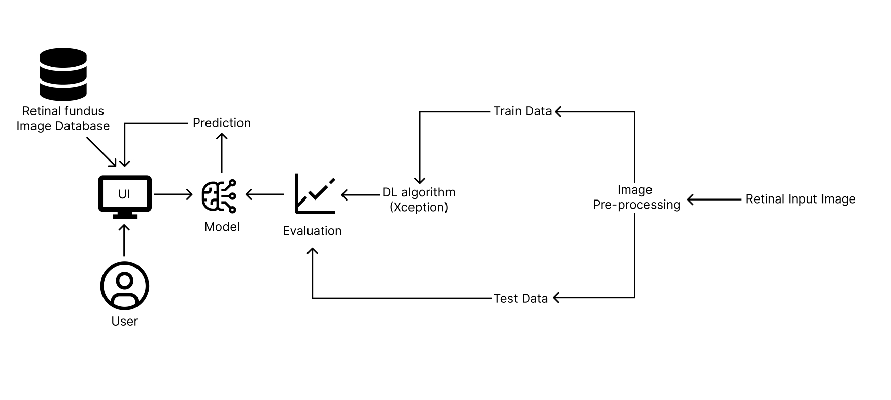

## CUSTOMER JOURNEY MAP:-

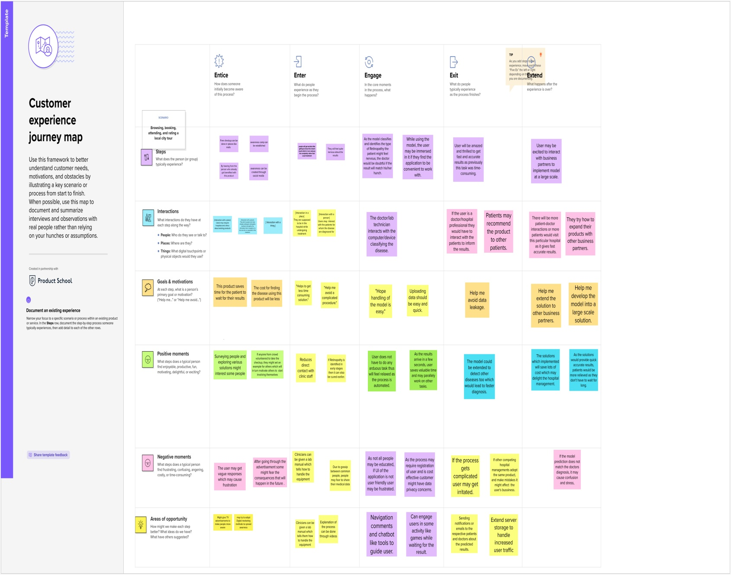

1. **PROJECT PLANNING AND SCHEDULING:-**

## SPRINT PLANNING AND ESTIMATION:-

|  |  |  |  |  |  |  |
| --- | --- | --- | --- | --- | --- | --- |
| **Sprint** | **Functional Requirement (Epic)** | **User Story Number** | **User Story / Task** | **Story Points** | **Priority** | **Team Members** |
| Sprint-1 | Registration | USN-1 | As a user, I can register for the application by  entering my email, and password, and confirming my password. | 10 | High | Srinidhi M |
| Sprint-1 | E-mail confirmation | USN-2 | As a user, I will receive a confirmation email once I have registered for the application | 10 | Medium | Sowmya M |
| Sprint-2 | Login | USN-3 | As a user, I can log into the application by entering my email & password | 5 | High | Srinidhi M  Vindhiya Sri U |
| Sprint-2 | Upload Images | USN-4 | As a user,I should be able to upload the image  of ECG. | 5 | High | Sowmya M  Vindhiya sri U |
| Sprint-2 | Dashboard | USN-5 | As a user, based on my requirement I can navigate through the dashboard. | 5 | Medium | varsha |

|  |  |  |  |  |  |  |
| --- | --- | --- | --- | --- | --- | --- |
| Sprint-3 | Train the model | Task 1 | As a developer, the dataset will be uploaded and trained by developed algorithm. | 20 | High | Srinidhi M Sowmya M |
| Sprint-4 | Testing & Evaluation | Task 2 | As a developer, we tested the trained model using the provided dataset and model will be evaluated for accurate results. | 10 | High | Varsha H Vindhiya Sri U |
| Sprint-4 | Display predicted result | USN-6 | As a user, I can view the predicted result in the dashboard. | 10 | High | Srinidhi M  Vindhiya Sri U |

# Project Tracker, Velocity & Burndown Chart:

|  |  |  |  |  |  |  |
| --- | --- | --- | --- | --- | --- | --- |
| **Sprint** | **Total Story Points** | **Duration** | **Sprint Start Date** | **Sprint End Date (Planned)** | **Story Points Completed (as on Planned End Date)** | **Sprint Release Date (Actual)** |
| Sprint-1 | 20 | 6 Days | 24 Oct 2022 | 29 Oct 2022 | 20 | 29 Oct 2022 |
| Sprint-2 | 20 | 6 Days | 31 Oct 2022 | 05 Nov 2022 | 20 | 05 Nov 2022 |
| Sprint-3 | 20 | 6 Days | 07 Nov 2022 | 12 Nov 2022 | 20 | 12 Nov 2022 |
| Sprint-4 | 20 | 6 Days | 14 Nov 2022 | 19 Nov 2022 | 20 | 19 Nov 2022 |

**Velocity:**

(AV) per iteration Imagine we have a 10-day sprint duration, and the velocity of the team is 20 (points per sprint). Let’s calculate the team’s average velocity unit (story points per day)



AV=20/6=3.33points per day

# BURNDOWN CHART

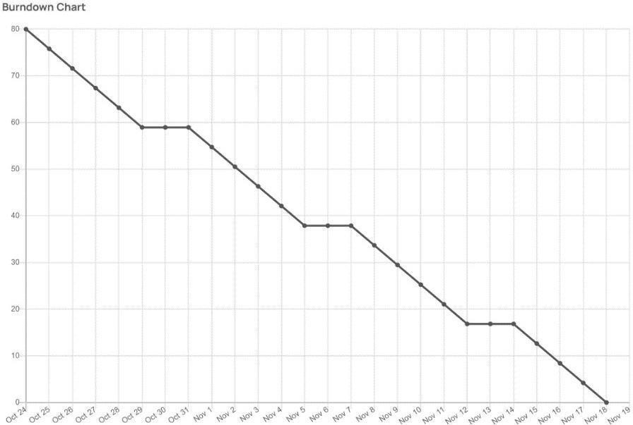

A burn down chart is a graphical representation of work left to do versus time. It is often used in agile [software development](https://www.visual-paradigm.com/scrum/what-is-agile-software-development/) methodologies such as [Scrum](https://www.visual-paradigm.com/scrum/scrum-in-3-minutes/). However, burn down charts can be applied to any project containing measurable progress over time.

<https://www.visual-paradigm.com/scrum/scrum-burndown-chart>

<https://www.atlassian.com/agile/tutorials/burndown-charts>

1. **CODING AND SOLUTIONING:-**

**Feature 1:-**

We have devloped a website which authenticates users and help them upload and check the seriousness of the diabetics.

### Feature 2:-

We have devloped a multilayer deep convolutional nueral network that classifies the user image of a eye to which extense has the disease diabetics has been affected.The model will classify the images into 5 categories of diabetics and report them on asking for prediction. We have also devloped a messaging service for recieiving message for the type of diabetics.

### TESTING:-

* 1. **TEST CASES:-**

### USER ACCEPTANCE TESTING:-

#### Purpose of Document:-

This document serves as a quick reference for the Deep Learning Fundus Image Analysis for Early Detection of Diabetic Retinopathy project's test coverage and open issues as

of the project's release for user acceptance testing.

#### Defect Analysis:-

This shows how many bugs were fixed or closed at each severity level and how they were fixed.

|  |  |  |  |  |  |
| --- | --- | --- | --- | --- | --- |
| **Resolution** | **Severity 1** | **Severity 2** | **Severity 3** | **Severity4** | **Subtotal** |
| By Design | 2 | 3 | 2 | 3 | 10 |
| Duplicate | 1 | 0 | 2 | 0 | 3 |
| External | 2 | 3 | 0 | 1 | 6 |
| Fixed | 8 | 2 | 5 | 9 | 24 |

|  |  |  |  |  |  |
| --- | --- | --- | --- | --- | --- |
| Not Reproduced | 0 | 1 | 1 | 0 | 2 |
| Skipped | 0 | 0 | 1 | 1 | 2 |
| Won'tFix | 0 | 4 | 1 | 1 | 6 |
| Totals | 13 | 13 | 12 | 15 | 53 |

#### Test-CaseAnalysis

This report shows the number of test cases that have passed, failed,and untested.

|  |  |  |  |  |
| --- | --- | --- | --- | --- |
| **Section** | **TotalCases** | **Not Tested** | **Fail** | **Pass** |
| PrintEngine | 9 | 0 | 0 | 9 |
| ClientApplication | 45 | 0 | 0 | 45 |
| Security | 2 | 0 | 0 | 2 |
| Out-sourceShipping | 3 | 0 | 0 | 3 |
| ExceptionReporting | 9 | 0 | 0 | 9 |
| FinalReportOutput | 4 | 0 | 0 | 4 |
| VersionControl | 2 | 0 | 0 | 2 |



## RESULTS:-

* 1. **Performance Metrics:- Model Performance Testing:**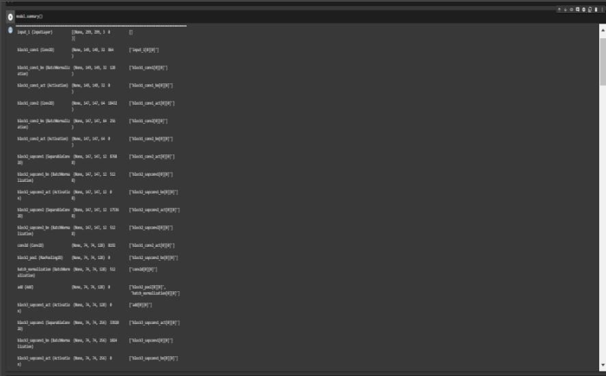

|  |  |  |  |
| --- | --- | --- | --- |
| **S. NO** | **Parameter** | **Values** | **Screenshot** |
| 1. | Model Summary | **Total params: 21,885,485**  **Trainable params: 1,024,005 Non-trainable params: 20,861,480** |  |
| 2. | Accuracy | Training Accuracy – **3.2610**  Validation Accuracy – **loss 0.7917** |  |
| 3. | Confidence Score(Only Yolo Projects) | Class Detected - Confidence  Score - | --  --  --  -- |

## ADVANTAGES AND DISADVANTAGES:-

* 1. **ADVANTAGES:-**

There are several advantages of using deep learning for fundus image analysis for early detection of diabetic retinopathy.

Firstly, deep learning is well-suited for image analysis tasks. This is because deep learning algorithms can automatically learn features from images, which is essential for accurate image analysis.

Secondly, deep learning is efficient at handling large amounts of data. This is important for medical image analysis, as medical images are often very large.

Thirdly, deep learning is scalable. This means that it can be used to train models on very large datasets, which is important for medical image analysis tasks where data is often limited.

Fourthly, deep learning is able to learn from data with little supervision. This is important for medical image analysis, as often there is limited labeled data available.

Finally, deep learning is robust. This means that it is less likely to overfit to the data, which is important for medical image analysis where data is often limited.

* 1. **DISADVANTAGES:-**

There are several disadvantages of deep learning for early detection of diabetic retinopathy.

One disadvantage is that deep learning requires a large amount of data to train the models. This can be a challenge for researchers who do not have access to a large dataset.

Another challenge is that deep learning models can be very complex, which can make them difficult to interpret. Finally, deep learning models can be computationally intensive, which can make them difficult to deploy in resource-limited settings.

1. **CONCLUSION:-**

Diabetic retinopathy (DR) is a leading cause of blindness in the United States. Early detection and treatment of DR is critical to preventing vision loss. However, DR is often asymptomatic in its early stages, making it difficult to detect.

Deep learning (DL) is a type of artificial intelligence that can be used to automatically detect patterns in data. DL has been shown to be effective for detecting DR in images of the retina.

In this study, a DL algorithm was used to automatically detect DR in fundus images. The algorithm was able to accurately detect DR in early stages, before it is symptomatic. This could potentially lead to earlier diagnosis and treatment of DR, which could help to prevent vision loss.

1. **FUTURE SCOPE:-**

There is a great potential for deep learning in fundus image analysis for early detection of diabetic retinopathy. However, there are a few challenges that need to be addressed. First, the current data sets are small and lack diversity. Second, the images are often low quality and need to be pre-processed before they can be used for deep learning.

Third, the ground truth labels for the images are often not available. Finally, the current deep learning models are not able to generalize well to real-world data.

1. **APPENDIX:-**

##### app.ipynb:-

**import** numpy **as** np

**import** os

**from** tensorflow.keras.models **import** load_model

**from** tensorflow.keras.preprocessing **import** image

**from** tensorflow.keras.applications.inception_v3 **import** preprocess_input

**from** cloudant.client **import** Cloudant

**from** werkzeug.utils **import** secure_filename

**from** flask **import** Flask, request, render_template, redirect, url_for,session

app**=**Flask(__name__)

client**=**Cloudant**.**iam('f17a994d-760b-40dc-baff-83fc3b995d7b-bluemix','69W0Zt5eGFE1LX4qtysIXCC4Xm-qG1l8ZyfpkpiS10oF',connect**=True**)

my_database **=** client['db']

app**.**secret_key**=**"SECRET_KEY"

model**=**load_model(r"inception-diabetic.h5")

image_folder**=**os**.**path**.**join('static','images')

app**.**config['UPLOAD_FOLDER'] **=** image_folder

@app**.**route('/')

**def** index():

full_filename **=** os**.**path**.**join(app**.**config['UPLOAD_FOLDER'], 'drimage.jpg')

**return** render_template('index.html',image**=**full_filename)

@app**.**route('/index')

**def** home():

full_filename **=** os**.**path**.**join(app**.**config['UPLOAD_FOLDER'], 'drimage.jpg')

**return** render_template('index.html',image**=**full_filename)

@app**.**route('/register')

**def** register():

full_filename **=** os**.**path**.**join(app**.**config['UPLOAD_FOLDER'], 'registerimg.jpg')

**return** render_template('register.html',image**=**full_filename)

@app**.**route('/afterreg',methods**=**['POST','GET'])

**def** afterreg():

x**=**[x **for** x **in** request**.**form**.**values()]

data**=**{

'_id':x[2],

'name':x[0],

'pwd':x[4],

'email':x[1],

'location':x[3],

'securityquestion':x[5],

'logintype':x[6]

}

query**=**{'_id':{'$eq':data['_id']}}

docs**=**my_database**.**get_query_result(query)

**if**(len(docs**.**all())**==**0):

url**=**my_database**.**create_document(data)

full_filename **=** os**.**path**.**join(app**.**config['UPLOAD_FOLDER'], 'loginimg.jpg')

**return** render_template('login.html',predict**=**"Registration successfull please login using your credentials",image**=**full_filename)

**else**:

full_filename **=** os**.**path**.**join(app**.**config['UPLOAD_FOLDER'], 'registerimg.jpg')

**return** render_template('register.html',pred**=**"You are already a member login using your credentials",image**=**full_filename)

@app**.**route('/login')

**def** login():

full_filename **=** os**.**path**.**join(app**.**config['UPLOAD_FOLDER'], 'loginimg.jpg')

**return** render_template('login.html',image**=**full_filename)

@app**.**route('/afterlogin', methods**=**['POST','GET'])

**def** afterlogin():

user**=**request**.**form['phoneno']

session['pn']**=**user

passw**=**request**.**form['pwd']

lgnas**=**request**.**form['loginas']

query**=**{'_id':{'$eq':user}}

docs**=**my_database**.**get_query_result(query)

**if**(len(docs**.**all())**==**0):

full_filename **=** os**.**path**.**join(app**.**config['UPLOAD_FOLDER'], 'loginimg.jpg')

**return** render_template('login.html',predict**=**"Phone number/id not found",image**=**full_filename)

**else**:

**if**((user**==**docs[0][0]['_id'] **and** passw**==**docs[0][0]['pwd'] **and** lgnas**==**docs[0][0]['logintype'] )):

**if**(docs[0][0]['logintype']**==**'user'):

full_filename **=** os**.**path**.**join(app**.**config['UPLOAD_FOLDER'], 'retina.jpg')

full_filename1 **=** os**.**path**.**join(app**.**config['UPLOAD_FOLDER'], 'image6.png')

**return** render_template('prediction.html',image**=**full_filename,image2**=**full_filename1)

**if**(docs[0][0]['logintype']**==**'admin'):

full_filename2 **=** os**.**path**.**join(app**.**config['UPLOAD_FOLDER'], 'adminimg.jpg')

**return** render_template('admin.html',image**=**full_filename2)

**if**(lgnas**!=**docs[0][0]['logintype']):

full_filename **=** os**.**path**.**join(app**.**config['UPLOAD_FOLDER'], 'loginimg.jpg')

**return** render_template('login.html',image**=**full_filename,predict**=**"Incorrect Logintype")

**if**(passw**!=**docs[0][0]['pwd']):

full_filename **=** os**.**path**.**join(app**.**config['UPLOAD_FOLDER'], 'loginimg.jpg')

**return** render_template('login.html',image**=**full_filename,predict**=**"Incorrect password")

@app**.**route('/respond')

**def** respond():

my_database_query **=** client['my_database_query']

dt**=**[]

**for** document **in** my_database_query:

dt**.**append(document['who'])

dt**.**append(document['phoneno'])

dt**.**append(document['query'])

**return** render_template('respond.html',data**=**dt)

@app**.**route('/afterrespond', methods**=**['POST','GET'])

**def** afterrespond():

my_database_query **=** client['my_database_query']

x**=**[x **for** x **in** request**.**form**.**values()]

data1**=**{

'_id':x[0],

'who':x[1],

'phoneno':x[2],

'query':x[3]

}

query**=**{'_id':{'$eq':data1['_id']}}

docs**=**my_database_query**.**get_query_result(query)

**if**(len(docs**.**all())**==**0):

url**=**my_database_query**.**create_document(data1)

my_database_query **=** client['my_database_query']

dt**=**[]

**for** document **in** my_database_query:

dt**.**append(document['who'])

dt**.**append(document['phoneno'])

dt**.**append(document['query'])

**return** render_template('respond.html',predict**=**"Response posted Successfully",data**=**dt)

**else**:

url**=**my_database_query**.**create_document(data1)

my_database_query **=** client['my_database_query']

dt**=**[]

**for** document **in** my_database_query:

dt**.**append(document['who'])

dt**.**append(document['phoneno'])

dt**.**append(document['query'])

**return** render_template('respond.html',predict**=**"Response posted Successfully",data**=**dt)

@app**.**route('/fp')

**def** fp():

full_filename **=** os**.**path**.**join(app**.**config['UPLOAD_FOLDER'],'forgotpw.png')

**return** render_template('fp.html',image**=**full_filename)

@app**.**route('/afterfp', methods**=**['POST','GET'])

**def** afterfp():

pn**=**request**.**form['phoneno']

securityques**=**request**.**form['secques']

npassw**=**request**.**form['npwd']

cpassw**=**request**.**form['cpwd']

docs**=**my_database[pn]

**if**(npassw**==**cpassw **and** securityques**==**docs['securityquestion']):

full_filename **=** os**.**path**.**join(app**.**config['UPLOAD_FOLDER'],'loginimg.jpg')

docs['pwd'] **=** cpassw

docs**.**save()

**return** render_template('login.html',predict**=**"Successfully updated",image**=**full_filename)

**if**(securityques**!=**docs['securityquestion']):

full_filename **=** os**.**path**.**join(app**.**config['UPLOAD_FOLDER'],'forgotpw.png')

**return** render_template('fp.html',predict**=**"Incorrect answer to security question",image**=**full_filename)

**if**(npassw**!=**cpassw):

full_filename **=** os**.**path**.**join(app**.**config['UPLOAD_FOLDER'],'forgotpw.png')

**return** render_template('fp.html',predict**=**"New and confirm password does not match",image**=**full_filename)

@app**.**route('/prediction')

**def** prediction():

full_filename **=** os**.**path**.**join(app**.**config['UPLOAD_FOLDER'], 'retina.jpg')

full_filename1 **=** os**.**path**.**join(app**.**config['UPLOAD_FOLDER'], 'image6.png')

**return** render_template('prediction.html',image**=**full_filename,image2**=**full_filename1)

@app**.**route('/afterpred',methods**=**["GET","POST"])

**def** aftepred():

**if** request**.**method**==**"POST":

full_filename2 **=** os**.**path**.**join(app**.**config['UPLOAD_FOLDER'], 'retina.jpg')

full_filename1 **=** os**.**path**.**join(app**.**config['UPLOAD_FOLDER'], 'image6.png')

f**=**request**.**files['pfile']

print("yes")

filepath**=**os**.**path**.**join('static','uploads',f**.**filename)

f**.**save(filepath)

print("saved")

img**=**image**.**load_img(filepath,target_size**=**(224,224))

x**=**image**.**img_to_array(img)

x**=**np**.**expand_dims(x,axis**=**0)

img_data**=**preprocess_input(x)

prediction**=**np**.**argmax(model**.**predict(img_data),axis**=**1)

index**=**["no dr","mild dr","moderate dr","severe dr","proliferate"]

result**=**str(index[prediction[0]])

print(result)

**return** render_template('prediction.html',prediction**=**result,image**=**full_filename2,image2**=**full_filename1)

**else**:

full_filename **=** os**.**path**.**join(app**.**config['UPLOAD_FOLDER'], 'loginimg.jpg')

**return** render_template('login.html',pred**=**"Please login using your credentials",image**=**full_filename)

@app**.**route('/query')

**def** query():

my_database_query **=** client['my_database_query']

dt**=**[]

**for** document **in** my_database_query:

dt**.**append(document['who'])

dt**.**append(document['phoneno'])

dt**.**append(document['query'])

**return** render_template('query1.html',data**=**dt)

@app**.**route('/afterquery', methods**=**['POST','GET'])

**def** afterquery():

my_database_query **=** client['my_database_query']

x**=**[x **for** x **in** request**.**form**.**values()]

data1**=**{

'_id':x[0],

'who':x[1],

'phoneno':x[2],

'query':x[3],

}

query**=**{'_id':{'$eq':data1['_id']}}

docs**=**my_database_query**.**get_query_result(query)

**if**(len(docs**.**all())**==**0):

url**=**my_database_query**.**create_document(data1)

my_database_query **=** client['my_database_query']

dt**=**[]

**for** document **in** my_database_query:

dt**.**append(document['who'])

dt**.**append(document['phoneno'])

dt**.**append(document['query'])

**return** render_template('query1.html',predict**=**"Query submitted Successfully",data**=**dt)

**else**:

url**=**my_database_query**.**create_document(data1)

my_database_query **=** client['my_database_query']

dt**=**[]

**for** document **in** my_database_query:

dt**.**append(document['who'])

dt**.**append(document['phoneno'])

dt**.**append(document['query'])

**return** render_template('query1.html',predict**=**"Query submitted Successfully",data**=**dt)

@app**.**route('/admin')

**def** admin():

full_filename2 **=** os**.**path**.**join(app**.**config['UPLOAD_FOLDER'], 'adminimg.png')

**return** render_template('admin.html',image**=**full_filename2)

@app**.**route('/locsugges')

**def** locsugess():

print("location")

dbl**=**client['db1']

dbu**=**client['db']

print("good")

pn**=**session['pn']

doc1**=**dbu[pn]

location**=**doc1["location"]

print("new")

docs**=**dbl[location**.**upper()]

hospital**=**[]

location**=**[]

**for** h **in** range(len(docs["hospitals"])):

hospital**.**append(docs['hospitals'][h])

**for** l **in** range(len(docs["locations"])):

location**.**append(docs['locations'][l])

full_filename **=** os**.**path**.**join(app**.**config['UPLOAD_FOLDER'])

**return** render_template('locsugges.html',hospital**=**hospital,location**=**location)

@app**.**route('/uploc')

**def** uploc():

full_filename **=** os**.**path**.**join(app**.**config['UPLOAD_FOLDER'])

**return** render_template('uploc.html')

@app**.**route('/afteruploc',methods**=**["GET","POST"])

**def** afteruploc():

loc**=**request**.**form['loch']

hname**=**request**.**form['hname']

lname**=**request**.**form['lname']

contact**=**request**.**form['contact']

dbl**=**client['db1']

docs**=**dbl[loc**.**upper()]

hn**=**hname**.**strip()**.**upper()

count**=**0

**for** i **in** range(len(docs['hospitals'])):

**if** docs['hospitals'][i]**.**strip()**.**upper()**==**hn:

docs['contacts'][i]**=**contact

docs['locations'][i]**=**lname

count**=**1

docs**.**save()

**break**

**if**(count**==**0):

docs['hospitals']**.**append(hn)

docs['contacts']**.**append(contact)

docs**.**save()

full_filename **=** os**.**path**.**join(app**.**config['UPLOAD_FOLDER'])

**return** render_template('uploc.html',predict**=**"Updated or added successfully")

@app**.**route('/modify',methods**=**["GET","POST"])

**def** modify():

full_filename **=** os**.**path**.**join(app**.**config['UPLOAD_FOLDER'])

**return** render_template('modify.html',predict**=**"Please enter your new location")

@app**.**route('/aftermodify',methods**=**["GET","POST"])

**def** aftermodify():

**if** request**.**method**==**"POST":

user**=**session['pn']

pwd**=**request**.**form['pwd']

nloc**=**request**.**form['location']

docs**=**my_database[user]

**if** (pwd**==**docs['pwd']):

full_filename **=** os**.**path**.**join(app**.**config['UPLOAD_FOLDER'],'pimg.jpg')

docs['location'] **=** nloc

docs**.**save()

**return** render_template('modify.html',predict**=**"Successfully updated")

**else**:

full_filename **=** os**.**path**.**join(app**.**config['UPLOAD_FOLDER'], 'retina.jpg')

full_filename1 **=** os**.**path**.**join(app**.**config['UPLOAD_FOLDER'], 'image6.png')

**return** render_template('prediction.html',image**=**full_filename,image2**=**full_filename1)

@app**.**route('/logout')

**def** logout():

session**.**pop('pn', **None**)

**return** render_template('logout.html',)

**if** __name__**==**"__main__":

app**.**run(debug**=False**)

**cloudcreation.ipynb**

**from** cloudant.client **import** Cloudant

pip install cloudant

Collecting cloudantNote: you may need to restart the kernel to use updated packages.

Downloading cloudant-2.15.0-py3-none-any.whl (80 kB)

Requirement already satisfied: requests<3.0.0,>=2.7.0 in d:\anaconda3\lib\site-packages (from cloudant) (2.27.1)

Requirement already satisfied: idna<4,>=2.5 in d:\anaconda3\lib\site-packages (from requests<3.0.0,>=2.7.0->cloudant) (3.3)

Requirement already satisfied: certifi>=2017.4.17 in d:\anaconda3\lib\site-packages (from requests<3.0.0,>=2.7.0->cloudant) (2021.10.8)

Requirement already satisfied: charset-normalizer~=2.0.0 in d:\anaconda3\lib\site-packages (from requests<3.0.0,>=2.7.0->cloudant) (2.0.4)

Requirement already satisfied: urllib3<1.27,>=1.21.1 in d:\anaconda3\lib\site-packages (from requests<3.0.0,>=2.7.0->cloudant) (1.26.9)

Installing collected packages: cloudant

Successfully installed cloudant-2.15.0

client**=**Cloudant**.**iam('username','apikey',connect**=True**)

my_database**=**client**.**create_database('my_database')

**querydb.ipynb**

**from** cloudant.client **import** Cloudant

client**=**Cloudant**.**iam('username','apikey',connect**=True**)

my_database**=**client**.**create_database('my_database_query')

**trainingmodel.ipynb**

imageSize **=** [299,299]

trainPath **=** r"C:\Users\deepa\Dropbox\My PC (LAPTOP-BPNC1U20)\Desktop\IBM\preprocessed dataset\preprocessed dataset\training"

testPath **=** r"C:\Users\deepa\Dropbox\My PC (LAPTOP-BPNC1U20)\Desktop\IBM\preprocessed dataset\preprocessed dataset\testing"

**from** tensorflow.keras.layers **import** Dense, Flatten, Input

**from** tensorflow.keras.models **import** Model

**from** tensorflow.keras.preprocessing **import** image

**from** tensorflow.keras.preprocessing.image **import** ImageDataGenerator,load_img

**from** tensorflow.keras.applications.xception **import** Xception,preprocess_input

**from** glob **import** glob

**import** numpy **as** np

**import** matplotlib.pyplot **as** plt

train_datagen **=** ImageDataGenerator(rescale**=**1.**/**255, shear_range **=** 0.2, zoom_range **=** 0.2, horizontal_flip **=** **True**)

test_datagen **=** ImageDataGenerator(rescale **=** 1.**/**255)

training_set **=** train_datagen**.**flow_from_directory(r"E:\GCT\SEM 7\nalaiyathiran\dataset\preprocessed dataset\preprocessed dataset\training",

target_size **=** (299,299),

batch_size **=** 32,

class_mode **=** 'categorical')

test_set **=** test_datagen**.**flow_from_directory(r"E:\GCT\SEM 7\nalaiyathiran\dataset\preprocessed dataset\preprocessed dataset\training",

target_size **=** (299,299),

batch_size **=** 32,

class_mode **=** 'categorical')

Found 3662 images belonging to 5 classes.

Found 3662 images belonging to 5 classes.

xception**=**Xception(input_shape **=** imageSize **+** [3], weights **=** 'imagenet', include_top**=** **False**)

Downloading data from https://storage.googleapis.com/tensorflow/keras-applications/xception/xception_weights_tf_dim_ordering_tf_kernels_notop.h5

83683744/83683744 [==============================] - 82s 1us/step

**for** layer **in** xception**.**layers:

layer**.**trainable **=** **False**

x **=** Flatten()(xception**.**output)

prediction **=** Dense(5, activation **=** 'softmax')(x)

model **=** Model(inputs**=**xception**.**input, outputs**=**prediction)

model**.**summary()

Model: "model"

__________________________________________________________________________________________________

Layer (type) Output Shape Param # Connected to

==================================================================================================

input_1 (InputLayer) [(None, 299, 299, 3 0 []

)]

block1_conv1 (Conv2D) (None, 149, 149, 32 864 ['input_1[0][0]']

)

block1_conv1_bn (BatchNormaliz (None, 149, 149, 32 128 ['block1_conv1[0][0]']

ation) )

block1_conv1_act (Activation) (None, 149, 149, 32 0 ['block1_conv1_bn[0][0]']

)

block1_conv2 (Conv2D) (None, 147, 147, 64 18432 ['block1_conv1_act[0][0]']

)

block1_conv2_bn (BatchNormaliz (None, 147, 147, 64 256 ['block1_conv2[0][0]']

ation) )

block1_conv2_act (Activation) (None, 147, 147, 64 0 ['block1_conv2_bn[0][0]']

)

block2_sepconv1 (SeparableConv (None, 147, 147, 12 8768 ['block1_conv2_act[0][0]']

2D) 8)

block2_sepconv1_bn (BatchNorma (None, 147, 147, 12 512 ['block2_sepconv1[0][0]']

lization) 8)

block2_sepconv2_act (Activatio (None, 147, 147, 12 0 ['block2_sepconv1_bn[0][0]']

n) 8)

block2_sepconv2 (SeparableConv (None, 147, 147, 12 17536 ['block2_sepconv2_act[0][0]']

2D) 8)

block2_sepconv2_bn (BatchNorma (None, 147, 147, 12 512 ['block2_sepconv2[0][0]']

lization) 8)

conv2d (Conv2D) (None, 74, 74, 128) 8192 ['block1_conv2_act[0][0]']

block2_pool (MaxPooling2D) (None, 74, 74, 128) 0 ['block2_sepconv2_bn[0][0]']

batch_normalization (BatchNorm (None, 74, 74, 128) 512 ['conv2d[0][0]']

alization)

add (Add) (None, 74, 74, 128) 0 ['block2_pool[0][0]',

'batch_normalization[0][0]']

block3_sepconv1_act (Activatio (None, 74, 74, 128) 0 ['add[0][0]']

n)

block3_sepconv1 (SeparableConv (None, 74, 74, 256) 33920 ['block3_sepconv1_act[0][0]']

2D)

block3_sepconv1_bn (BatchNorma (None, 74, 74, 256) 1024 ['block3_sepconv1[0][0]']

lization)

block3_sepconv2_act (Activatio (None, 74, 74, 256) 0 ['block3_sepconv1_bn[0][0]']

n)

block3_sepconv2 (SeparableConv (None, 74, 74, 256) 67840 ['block3_sepconv2_act[0][0]']

2D)

block3_sepconv2_bn (BatchNorma (None, 74, 74, 256) 1024 ['block3_sepconv2[0][0]']

lization)

conv2d_1 (Conv2D) (None, 37, 37, 256) 32768 ['add[0][0]']

block3_pool (MaxPooling2D) (None, 37, 37, 256) 0 ['block3_sepconv2_bn[0][0]']

batch_normalization_1 (BatchNo (None, 37, 37, 256) 1024 ['conv2d_1[0][0]']

rmalization)

add_1 (Add) (None, 37, 37, 256) 0 ['block3_pool[0][0]',

'batch_normalization_1[0][0]']

block4_sepconv1_act (Activatio (None, 37, 37, 256) 0 ['add_1[0][0]']

n)

block4_sepconv1 (SeparableConv (None, 37, 37, 728) 188672 ['block4_sepconv1_act[0][0]']

2D)

block4_sepconv1_bn (BatchNorma (None, 37, 37, 728) 2912 ['block4_sepconv1[0][0]']

lization)

block4_sepconv2_act (Activatio (None, 37, 37, 728) 0 ['block4_sepconv1_bn[0][0]']

n)

block4_sepconv2 (SeparableConv (None, 37, 37, 728) 536536 ['block4_sepconv2_act[0][0]']

2D)

block4_sepconv2_bn (BatchNorma (None, 37, 37, 728) 2912 ['block4_sepconv2[0][0]']

lization)

conv2d_2 (Conv2D) (None, 19, 19, 728) 186368 ['add_1[0][0]']

block4_pool (MaxPooling2D) (None, 19, 19, 728) 0 ['block4_sepconv2_bn[0][0]']

batch_normalization_2 (BatchNo (None, 19, 19, 728) 2912 ['conv2d_2[0][0]']

rmalization)

add_2 (Add) (None, 19, 19, 728) 0 ['block4_pool[0][0]',

'batch_normalization_2[0][0]']

block5_sepconv1_act (Activatio (None, 19, 19, 728) 0 ['add_2[0][0]']

n)

block5_sepconv1 (SeparableConv (None, 19, 19, 728) 536536 ['block5_sepconv1_act[0][0]']

2D)

block5_sepconv1_bn (BatchNorma (None, 19, 19, 728) 2912 ['block5_sepconv1[0][0]']

lization)

block5_sepconv2_act (Activatio (None, 19, 19, 728) 0 ['block5_sepconv1_bn[0][0]']

n)

block5_sepconv2 (SeparableConv (None, 19, 19, 728) 536536 ['block5_sepconv2_act[0][0]']

2D)

block5_sepconv2_bn (BatchNorma (None, 19, 19, 728) 2912 ['block5_sepconv2[0][0]']

lization)

block5_sepconv3_act (Activatio (None, 19, 19, 728) 0 ['block5_sepconv2_bn[0][0]']

n)

block5_sepconv3 (SeparableConv (None, 19, 19, 728) 536536 ['block5_sepconv3_act[0][0]']

2D)

block5_sepconv3_bn (BatchNorma (None, 19, 19, 728) 2912 ['block5_sepconv3[0][0]']

lization)

add_3 (Add) (None, 19, 19, 728) 0 ['block5_sepconv3_bn[0][0]',

'add_2[0][0]']

block6_sepconv1_act (Activatio (None, 19, 19, 728) 0 ['add_3[0][0]']

n)

block6_sepconv1 (SeparableConv (None, 19, 19, 728) 536536 ['block6_sepconv1_act[0][0]']

2D)

block6_sepconv1_bn (BatchNorma (None, 19, 19, 728) 2912 ['block6_sepconv1[0][0]']

lization)

block6_sepconv2_act (Activatio (None, 19, 19, 728) 0 ['block6_sepconv1_bn[0][0]']

n)

block6_sepconv2 (SeparableConv (None, 19, 19, 728) 536536 ['block6_sepconv2_act[0][0]']

2D)

block6_sepconv2_bn (BatchNorma (None, 19, 19, 728) 2912 ['block6_sepconv2[0][0]']

lization)

block6_sepconv3_act (Activatio (None, 19, 19, 728) 0 ['block6_sepconv2_bn[0][0]']

n)

block6_sepconv3 (SeparableConv (None, 19, 19, 728) 536536 ['block6_sepconv3_act[0][0]']

2D)

block6_sepconv3_bn (BatchNorma (None, 19, 19, 728) 2912 ['block6_sepconv3[0][0]']

lization)

add_4 (Add) (None, 19, 19, 728) 0 ['block6_sepconv3_bn[0][0]',

'add_3[0][0]']

block7_sepconv1_act (Activatio (None, 19, 19, 728) 0 ['add_4[0][0]']

n)

block7_sepconv1 (SeparableConv (None, 19, 19, 728) 536536 ['block7_sepconv1_act[0][0]']

2D)

block7_sepconv1_bn (BatchNorma (None, 19, 19, 728) 2912 ['block7_sepconv1[0][0]']

lization)

block7_sepconv2_act (Activatio (None, 19, 19, 728) 0 ['block7_sepconv1_bn[0][0]']

n)

block7_sepconv2 (SeparableConv (None, 19, 19, 728) 536536 ['block7_sepconv2_act[0][0]']

2D)

block7_sepconv2_bn (BatchNorma (None, 19, 19, 728) 2912 ['block7_sepconv2[0][0]']

lization)

block7_sepconv3_act (Activatio (None, 19, 19, 728) 0 ['block7_sepconv2_bn[0][0]']

n)

block7_sepconv3 (SeparableConv (None, 19, 19, 728) 536536 ['block7_sepconv3_act[0][0]']

2D)

block7_sepconv3_bn (BatchNorma (None, 19, 19, 728) 2912 ['block7_sepconv3[0][0]']

lization)

add_5 (Add) (None, 19, 19, 728) 0 ['block7_sepconv3_bn[0][0]',

'add_4[0][0]']

block8_sepconv1_act (Activatio (None, 19, 19, 728) 0 ['add_5[0][0]']

n)

block8_sepconv1 (SeparableConv (None, 19, 19, 728) 536536 ['block8_sepconv1_act[0][0]']

2D)

block8_sepconv1_bn (BatchNorma (None, 19, 19, 728) 2912 ['block8_sepconv1[0][0]']

lization)

block8_sepconv2_act (Activatio (None, 19, 19, 728) 0 ['block8_sepconv1_bn[0][0]']

n)

block8_sepconv2 (SeparableConv (None, 19, 19, 728) 536536 ['block8_sepconv2_act[0][0]']

2D)

block8_sepconv2_bn (BatchNorma (None, 19, 19, 728) 2912 ['block8_sepconv2[0][0]']

lization)

block8_sepconv3_act (Activatio (None, 19, 19, 728) 0 ['block8_sepconv2_bn[0][0]']

n)

block8_sepconv3 (SeparableConv (None, 19, 19, 728) 536536 ['block8_sepconv3_act[0][0]']

2D)

block8_sepconv3_bn (BatchNorma (None, 19, 19, 728) 2912 ['block8_sepconv3[0][0]']

lization)

add_6 (Add) (None, 19, 19, 728) 0 ['block8_sepconv3_bn[0][0]',

'add_5[0][0]']

block9_sepconv1_act (Activatio (None, 19, 19, 728) 0 ['add_6[0][0]']

n)

block9_sepconv1 (SeparableConv (None, 19, 19, 728) 536536 ['block9_sepconv1_act[0][0]']

2D)

block9_sepconv1_bn (BatchNorma (None, 19, 19, 728) 2912 ['block9_sepconv1[0][0]']

lization)

block9_sepconv2_act (Activatio (None, 19, 19, 728) 0 ['block9_sepconv1_bn[0][0]']

n)

block9_sepconv2 (SeparableConv (None, 19, 19, 728) 536536 ['block9_sepconv2_act[0][0]']

2D)

block9_sepconv2_bn (BatchNorma (None, 19, 19, 728) 2912 ['block9_sepconv2[0][0]']

lization)

block9_sepconv3_act (Activatio (None, 19, 19, 728) 0 ['block9_sepconv2_bn[0][0]']

n)

block9_sepconv3 (SeparableConv (None, 19, 19, 728) 536536 ['block9_sepconv3_act[0][0]']

2D)

block9_sepconv3_bn (BatchNorma (None, 19, 19, 728) 2912 ['block9_sepconv3[0][0]']

lization)

add_7 (Add) (None, 19, 19, 728) 0 ['block9_sepconv3_bn[0][0]',

'add_6[0][0]']

block10_sepconv1_act (Activati (None, 19, 19, 728) 0 ['add_7[0][0]']

on)

block10_sepconv1 (SeparableCon (None, 19, 19, 728) 536536 ['block10_sepconv1_act[0][0]']

v2D)

block10_sepconv1_bn (BatchNorm (None, 19, 19, 728) 2912 ['block10_sepconv1[0][0]']

alization)

block10_sepconv2_act (Activati (None, 19, 19, 728) 0 ['block10_sepconv1_bn[0][0]']

on)

block10_sepconv2 (SeparableCon (None, 19, 19, 728) 536536 ['block10_sepconv2_act[0][0]']

v2D)

block10_sepconv2_bn (BatchNorm (None, 19, 19, 728) 2912 ['block10_sepconv2[0][0]']

alization)

block10_sepconv3_act (Activati (None, 19, 19, 728) 0 ['block10_sepconv2_bn[0][0]']

on)

block10_sepconv3 (SeparableCon (None, 19, 19, 728) 536536 ['block10_sepconv3_act[0][0]']

v2D)

block10_sepconv3_bn (BatchNorm (None, 19, 19, 728) 2912 ['block10_sepconv3[0][0]']

alization)

add_8 (Add) (None, 19, 19, 728) 0 ['block10_sepconv3_bn[0][0]',

'add_7[0][0]']

block11_sepconv1_act (Activati (None, 19, 19, 728) 0 ['add_8[0][0]']

on)

block11_sepconv1 (SeparableCon (None, 19, 19, 728) 536536 ['block11_sepconv1_act[0][0]']

v2D)

block11_sepconv1_bn (BatchNorm (None, 19, 19, 728) 2912 ['block11_sepconv1[0][0]']

alization)

block11_sepconv2_act (Activati (None, 19, 19, 728) 0 ['block11_sepconv1_bn[0][0]']

on)

block11_sepconv2 (SeparableCon (None, 19, 19, 728) 536536 ['block11_sepconv2_act[0][0]']

v2D)

block11_sepconv2_bn (BatchNorm (None, 19, 19, 728) 2912 ['block11_sepconv2[0][0]']

alization)

block11_sepconv3_act (Activati (None, 19, 19, 728) 0 ['block11_sepconv2_bn[0][0]']

on)

block11_sepconv3 (SeparableCon (None, 19, 19, 728) 536536 ['block11_sepconv3_act[0][0]']

v2D)

block11_sepconv3_bn (BatchNorm (None, 19, 19, 728) 2912 ['block11_sepconv3[0][0]']

alization)

add_9 (Add) (None, 19, 19, 728) 0 ['block11_sepconv3_bn[0][0]',

'add_8[0][0]']

block12_sepconv1_act (Activati (None, 19, 19, 728) 0 ['add_9[0][0]']

on)

block12_sepconv1 (SeparableCon (None, 19, 19, 728) 536536 ['block12_sepconv1_act[0][0]']

v2D)

block12_sepconv1_bn (BatchNorm (None, 19, 19, 728) 2912 ['block12_sepconv1[0][0]']

alization)

block12_sepconv2_act (Activati (None, 19, 19, 728) 0 ['block12_sepconv1_bn[0][0]']

on)

block12_sepconv2 (SeparableCon (None, 19, 19, 728) 536536 ['block12_sepconv2_act[0][0]']

v2D)

block12_sepconv2_bn (BatchNorm (None, 19, 19, 728) 2912 ['block12_sepconv2[0][0]']

alization)

block12_sepconv3_act (Activati (None, 19, 19, 728) 0 ['block12_sepconv2_bn[0][0]']

on)

block12_sepconv3 (SeparableCon (None, 19, 19, 728) 536536 ['block12_sepconv3_act[0][0]']

v2D)

block12_sepconv3_bn (BatchNorm (None, 19, 19, 728) 2912 ['block12_sepconv3[0][0]']

alization)

add_10 (Add) (None, 19, 19, 728) 0 ['block12_sepconv3_bn[0][0]',

'add_9[0][0]']

block13_sepconv1_act (Activati (None, 19, 19, 728) 0 ['add_10[0][0]']

on)

block13_sepconv1 (SeparableCon (None, 19, 19, 728) 536536 ['block13_sepconv1_act[0][0]']

v2D)

block13_sepconv1_bn (BatchNorm (None, 19, 19, 728) 2912 ['block13_sepconv1[0][0]']

alization)

block13_sepconv2_act (Activati (None, 19, 19, 728) 0 ['block13_sepconv1_bn[0][0]']

on)

block13_sepconv2 (SeparableCon (None, 19, 19, 1024 752024 ['block13_sepconv2_act[0][0]']

v2D) )

block13_sepconv2_bn (BatchNorm (None, 19, 19, 1024 4096 ['block13_sepconv2[0][0]']

alization) )

conv2d_3 (Conv2D) (None, 10, 10, 1024 745472 ['add_10[0][0]']

)

block13_pool (MaxPooling2D) (None, 10, 10, 1024 0 ['block13_sepconv2_bn[0][0]']

)

batch_normalization_3 (BatchNo (None, 10, 10, 1024 4096 ['conv2d_3[0][0]']

rmalization) )

add_11 (Add) (None, 10, 10, 1024 0 ['block13_pool[0][0]',

) 'batch_normalization_3[0][0]']

block14_sepconv1 (SeparableCon (None, 10, 10, 1536 1582080 ['add_11[0][0]']

v2D) )

block14_sepconv1_bn (BatchNorm (None, 10, 10, 1536 6144 ['block14_sepconv1[0][0]']

alization) )

block14_sepconv1_act (Activati (None, 10, 10, 1536 0 ['block14_sepconv1_bn[0][0]']

on) )

block14_sepconv2 (SeparableCon (None, 10, 10, 2048 3159552 ['block14_sepconv1_act[0][0]']

v2D) )

block14_sepconv2_bn (BatchNorm (None, 10, 10, 2048 8192 ['block14_sepconv2[0][0]']

alization) )

block14_sepconv2_act (Activati (None, 10, 10, 2048 0 ['block14_sepconv2_bn[0][0]']

on) )

flatten (Flatten) (None, 204800) 0 ['block14_sepconv2_act[0][0]']

dense (Dense) (None, 5) 1024005 ['flatten[0][0]']

==================================================================================================

Total params: 21,885,485

Trainable params: 1,024,005

Non-trainable params: 20,861,480

__________________________________________________________________________________________________

model**.**compile(loss**=**'categorical_crossentropy',optimizer**=**'adam',metrics**=**['accuracy'])

r **=** model**.**fit_generator(training_set,

validation_data**=**test_set,

epochs**=**30,

steps_per_epoch**=**len(training_set)**//**32,

validation_steps**=**len(test_set)**//**32

)

**admin.html**

|  |
| --- |
| <!DOCTYPE html> |
|  | <html> |
|  | <head> |
|  | <title>Deep learning fundus image analysis for early detection of Diabetic Retinopathy</title> |
|  | <link rel="stylesheet" href="https://fonts.googleapis.com/css?family=Roboto"> |
|  | </head> |
|  | <style> |
|  | html,body{ |
|  | margin:0; |
|  | width:100%; |
|  | height:100%; |
|  | font-family:Roboto; |
|  | display: flex; |
|  | flex-direction: column; |
|  | } |
|  | .header{ |
|  | position: fixed; |
|  | top: 0px; |
|  | width:100%; |
|  | height:100px; |
|  | background-color:dimgrey; |
|  | display: flex; |
|  | flex-direction: row; |
|  | align-items: center; |
|  | justify-content: space-between; |
|  | } |
|  | #heading{ |
|  | padding:10px; |
|  | color:white; |
|  | font-size:25px; |
|  | font-style: italic |
|  | } |
|  | #option1{ |
|  | margin-right:2px; |
|  | padding:10px; |
|  | color:white; |
|  | font-size:20px; |
|  | } |
|  | .options{ |
|  | display: flex; |
|  | } |
|  | a{ |
|  | text-decoration:none; |
|  | color:white; |
|  | } |
|  | #option1:hover{ |
|  | border:1px solid white; |
|  | border-radius:10px; |
|  | background-color:black; |
|  | } |
|  | .container{ |
|  | margin-top: 100px; |
|  | display: flex; |
|  | flex-direction: row; |
|  | align-items: center; |
|  | justify-content: center; |
|  | border:2px solid black; |
|  | } |
|  | #imgs{ |
|  | margin-top:50px; |
|  | height: 300px; |
|  | width: 300px; |
|  | } |
|  | #subhead{ |
|  | font-size: 30px; |
|  | color: coral; |
|  | text-align: center; |
|  | text-decoration-line: underline; |
|  | } |
|  | th, td { |
|  | width:40vw; |
|  | padding: 15px; |
|  | } |
|  | th{ |
|  | color:darkgreen; |
|  | text-decoration-line: underline; |
|  | } |
|  | td{ |
|  | color:brown; |
|  | text-align:justify; |
|  | } |
|  | </style> |
|  | <body> |
|  | <div class="header"> |
|  | <p id="heading">Welcome Admin</p> |
|  | <div class="options"> |
|  | <p id="option1"><a href="respond">Respond Queries</a></p> |
|  | <p id="option1"><a href="uploc">Update locations</a></p> |
|  | <p id="option1"><a href="logout">Logout</a></p> |
|  | </div> |
|  | </div> |
|  | <div class="container"> |
|  | <img id="imgs", src="{{image}}",alt="DR Image"><br> |
|  | </div> |
|  | <div> |
|  | <p id="subhead">About Project</p> |
|  | </div> |
|  | <table> |
|  | <tr><th>Problem</th> |
|  | <th>Solution</th> |
|  | <tr><td><br>Diabetic Retinopathy (DR) is a common complication of diabetes mellitus, which causes lesions on the |
|  | retina that affect vision. If it is not detected early, it can lead to blindness. Unfortunately, DR is not |
|  | a reversible process, and treatment only sustains vision. DR early detection and treatment can |
|  | significantly reduce the risk of vision loss. The manual diagnosis process of DR retina fundus images by |
|  | ophthalmologists is time, effort and cost-consuming and prone to misdiagnosis unlike computer-aided |
|  | diagnosis systems.</td> |
|  | <td>Transfer learning has become one of the most common techniques that has achieved better |
|  | performance in many areas, especially in medical image analysis and classification. We used Transfer |
|  | Learning techniques like Inception V3,Resnet50,Xception V3 that are more widely used as a transfer |
|  | learning method in medical image analysis and they are highly effective.</td> |
|  | </table> |
|  |  |
|  |  |
|  | </body> |
|  | </html> |

**fp.html**

|  |
| --- |
| <!DOCTYPE html> |
|  | <html> |
|  | <head> |
|  | <title>Deep learning fundus image analysis for early detection of Diabetic Retinopathy</title> |
|  | <link rel="stylesheet" href="https://fonts.googleapis.com/css?family=Roboto"> |
|  | </head> |
|  | <style> |
|  | html,body{ |
|  | margin:0; |
|  | width:100%; |
|  | height:100%; |
|  | font-family:Roboto; |
|  | display: flex; |
|  | flex-direction: column; |
|  | } |
|  | .header{ |
|  | position: fixed; |
|  | top: 0px; |
|  | width:100%; |
|  | height:100px; |
|  | background-color:dimgrey; |
|  | display: flex; |
|  | flex-direction: row; |
|  | align-items: center; |
|  | justify-content: space-between; |
|  | } |
|  | #heading{ |
|  | padding:10px; |
|  | color:white; |
|  | font-size:25px; |
|  | font-style: italic |
|  | } |
|  | #option1{ |
|  | margin-right:2px; |
|  | padding:10px; |
|  | color:white; |
|  | font-size:20px; |
|  | } |
|  | .options{ |
|  | display: flex; |
|  | } |
|  | a{ |
|  | text-decoration:none; |
|  | color:white; |
|  | } |
|  | #option1:hover{ |
|  | border:1px solid white; |
|  | border-radius:10px; |
|  | background-color:black; |
|  | } |
|  | .content{ |
|  | margin:auto; |
|  | } |
|  | .frm{ |
|  | margin-top: 100px; |
|  | border:2px solid black; |
|  | padding:30px; |
|  | border-radius:5px; |
|  | } |
|  | .inputs{ |
|  | padding:10px; |
|  | border-radius:5px; |
|  | outline:0; |
|  | width:250px; |
|  | } |
|  | .btn{ |
|  | cursor: pointer; |
|  | width:-webkit-fill-available; |
|  | } |
|  | .si:hover{ |
|  | color:white; |
|  | background-color:dimgrey; |
|  | } |
|  | img{ |
|  | height:90px; |
|  | width:90px; |
|  | border-radius:50%; |
|  | } |
|  | </style> |
|  | <body> |
|  | <div class="header"> |
|  | <p id="heading">FORGOT PASSWORD</p> |
|  | <div class="options"> |
|  | <p id="option1"><a href="index">Home</a></p> |
|  | </div> |
|  | </div> |
|  |  |
|  | <div class="content"> |
|  | <center><p style="color: blue;margin-top: 100px;">{{predict}}</p></center><br> |
|  | <form class="frm" action="http://127.0.0.1:5000/afterfp" method="POST"> |
|  | <h3><center><img src="{{image}}"alt="forgotpw"></center></h3> |
|  | <input type="text" class="inputs" placeholder="Phone number" name="phoneno" required><br><br> |
|  | <input type="text" class="inputs" placeholder="Your favourite pet(Security Question)" name="secques" required><br><br> |
|  | <input type="password" class="inputs" placeholder="New Password" name="npwd" required><br><br> |
|  | <input type="password" class="inputs" placeholder="Confirm Password" name="cpwd" required><br><br> |
|  | <button type="submit" class="inputs btn si" >Submit</button> |
|  | <br><br> |
|  |  |
|  | </form> |
|  | </div> |
|  |  |
|  |  |
|  | </body> |
|  | </html> |

## index.html

|  |
| --- |
| <!DOCTYPE html> |
|  | <html> |
|  | <head> |
|  | <title>Deep learning fundus image analysis for early detection of Diabetic Retinopathy</title> |
|  | <link rel="stylesheet" href="https://fonts.googleapis.com/css?family=Roboto"> |
|  | </head> |
|  | <style> |
|  | html,body{ |
|  | margin:0; |
|  | width:100%; |
|  | height:100%; |
|  | font-family:Roboto; |
|  | display: flex; |
|  | flex-direction: column; |
|  | } |
|  | .header{ |
|  | position: fixed; |
|  | top: 0px; |
|  | width:100%; |
|  | height:100px; |
|  | background-color:dimgrey; |
|  | display: flex; |
|  | flex-direction: row; |
|  | align-items: center; |
|  | justify-content: space-between; |
|  | } |
|  | #heading{ |
|  | padding:10px; |
|  | color:white; |
|  | font-size:25px; |
|  | font-style: italic |
|  | } |
|  | #option1{ |
|  | margin-right:2px; |
|  | padding:10px; |
|  | color:white; |
|  | font-size:20px; |
|  | } |
|  | .options{ |
|  | display: flex; |
|  | } |
|  | a{ |
|  | text-decoration:none; |
|  | color:white; |
|  | } |
|  | #option1:hover{ |
|  | border:1px solid white; |
|  | border-radius:10px; |
|  | background-color:black; |
|  | } |
|  | .container{ |
|  | display:flex; |
|  | justify-content:center; |
|  | align-items: center |
|  | flex-direction:row; |
|  | } |
|  | #imgs{ |
|  | margin-top:100px; |
|  | height: 300px; |
|  | width: 60vw; |
|  | } |
|  | #subhead{ |
|  | font-size: 30px; |
|  | color: coral; |
|  | text-align: center; |
|  | text-decoration-line: underline; |
|  | } |
|  | th, td { |
|  | width:40vw; |
|  | padding: 15px; |
|  | } |
|  | th{ |
|  | color:darkgreen; |
|  | text-decoration-line: underline; |
|  | } |
|  | td{ |
|  | color:brown; |
|  | text-align:justify; |
|  | } |
|  |  |
|  | </style> |
|  | <body> |
|  | <div class="header"> |
|  | <p id="heading">Deep learning fundus image analysis for early detection of diabetic retinopathy</p> |
|  | <div class="options"> |
|  | <p id="option1"><a href="index">Home</a></p> |
|  | <p id="option1"><a href="register">Register</a></p> |
|  | <p id="option1"><a href="login">Login</a></p> |
|  | <p id="option1"><a href="query">Query</a></p> |
|  | </div> |
|  | </div> |
|  | <div class="container"> |
|  | <img id="imgs", src="{{image}}",alt="DR Image"><br> |
|  | </div> |
|  | <div> |
|  | <p id="subhead">About Project</p> |
|  | </div> |
|  | <table> |
|  | <tr><th>Problem</th> |
|  | <th>Solution</th> |
|  | <tr><td><br>Diabetic Retinopathy (DR) is a common complication of diabetes mellitus, which causes lesions on the |
|  | retina that affect vision. If it is not detected early, it can lead to blindness. Unfortunately, DR is not |
|  | a reversible process, and treatment only sustains vision. DR early detection and treatment can |
|  | significantly reduce the risk of vision loss. The manual diagnosis process of DR retina fundus images by |
|  | ophthalmologists is time, effort and cost-consuming and prone to misdiagnosis unlike computer-aided |
|  | diagnosis systems.</td> |
|  | <td>Transfer learning has become one of the most common techniques that has achieved better |
|  | performance in many areas, especially in medical image analysis and classification. We used Transfer |
|  | Learning techniques like Inception V3,Resnet50,Xception V3 that are more widely used as a transfer |
|  | learning method in medical image analysis and they are highly effective.</td> |
|  | </table> |
|  |  |
|  |  |
|  | </body> |
|  | </html> |

## ****locsugges.html****

|  |
| --- |
| <!DOCTYPE html> |
|  | <html> |
|  | <head> |
|  | <title>Deep learning fundus image analysis for early detection of Diabetic Retinopathy</title> |
|  | <link rel="stylesheet" href="https://fonts.googleapis.com/css?family=Roboto"> |
|  | </head> |
|  | <style> |
|  | html,body{ |
|  | margin:0; |
|  | width:100%; |
|  | height:100%; |
|  | font-family:Roboto; |
|  | display: flex; |
|  | flex-direction: column; |
|  | } |
|  | th{ |
|  | padding-top: 10px; |
|  | padding-bottom: 20px; |
|  | padding-left: 30px; |
|  | padding-right: 40px; |
|  | color:black; |
|  | } |
|  | td { |
|  | padding-top: 10px; |
|  | padding-bottom: 20px; |
|  | padding-left: 30px; |
|  | padding-right: 40px; |
|  | color:teal; |
|  | } |
|  |  |
|  |  |
|  | .header{ |
|  | position: fixed; |
|  | top: 0px; |
|  | width:100%; |
|  | height:100px; |
|  | background-color:dimgrey; |
|  | display: flex; |
|  | flex-direction: row; |
|  | align-items: center; |
|  | justify-content: space-between; |
|  | } |
|  | #heading{ |
|  | padding:10px; |
|  | color:white; |
|  | font-size:25px; |
|  | font-style: italic |
|  | } |
|  | #option1{ |
|  | margin-right:2px; |
|  | padding:10px; |
|  | color:white; |
|  | font-size:20px; |
|  | } |
|  | .options{ |
|  | display: flex; |
|  | } |
|  | a{ |
|  | text-decoration:none; |
|  | color:white; |
|  | } |
|  | #option1:hover{ |
|  | border:1px solid white; |
|  | border-radius:10px; |
|  | background-color:black; |
|  | } |
|  | .content{ |
|  | margin:auto; |
|  | } |
|  | .frm{ |
|  | margin-top: 100px; |
|  | border:2px solid black; |
|  | padding:30px; |
|  | border-radius:5px; |
|  | } |
|  | .inputs{ |
|  | padding:10px; |
|  | border-radius:5px; |
|  | outline:0; |
|  | width:250px; |
|  | } |
|  | .btn{ |
|  | cursor: pointer; |
|  | width:-webkit-fill-available; |
|  | } |
|  | .si:hover{ |
|  | color:white; |
|  | background-color:dimgrey; |
|  | } |
|  |  |
|  | </style> |
|  | <body> |
|  | <div class="header"> |
|  | <p id="heading">Hospitals Near You</p> |
|  | <div class="options"> |
|  | <p id="option1"><a href="index">Home</a></p> |
|  | <p id="option1"><a href="prediction">Back</a></p> |
|  | </div> |
|  | </div> |
|  |  |
|  | <div class="content"> |
|  | <table> |
|  | {% set i=0 %} |
|  | <tr> |
|  | <th>HOSPITALS</th> |
|  | <th>LOCATIONS</th> |
|  | <th>CONTACTS</th> |
|  | </tr> |
|  | {% for i in range(hospital|length)%} |
|  | <tr><td>{{hospital[i]}}</td> |
|  | <td>{{location[i] }}</td> |
|  | <td>{{contact[i] }}</td></tr> |
|  | {% set i=i+1 %} |
|  | {% endfor %} |
|  | </table> |
|  |  |
|  | </div> |
|  |  |
|  |  |
|  | </body> |
|  | </html> |

**Login.html**

|  |
| --- |
| <!DOCTYPE html> |
|  | <html> |
|  | <head> |
|  | <title>Deep learning fundus image analysis for early detection of Diabetic Retinopathy</title> |
|  | <link rel="stylesheet" href="https://fonts.googleapis.com/css?family=Roboto"> |
|  | </head> |
|  | <style> |
|  | html,body{ |
|  | margin:0; |
|  | width:100%; |
|  | height:100%; |
|  | font-family:Roboto; |
|  | display: flex; |
|  | flex-direction: column; |
|  | } |
|  | .header{ |
|  | position: fixed; |
|  | top: 0px; |
|  | width:100%; |
|  | height:100px; |
|  | background-color:dimgrey; |
|  | display: flex; |
|  | flex-direction: row; |
|  | align-items: center; |
|  | justify-content: space-between; |
|  | } |
|  | #heading{ |
|  | padding:10px; |
|  | color:white; |
|  | font-size:25px; |
|  | font-style: italic |
|  | } |
|  | #option1{ |
|  | margin-right:2px; |
|  | padding:10px; |
|  | color:white; |
|  | font-size:20px; |
|  | } |
|  | .options{ |
|  | display: flex; |
|  | } |
|  | a{ |
|  | text-decoration:none; |
|  | color:white; |
|  | } |
|  | #option1:hover{ |
|  | border:1px solid white; |
|  | border-radius:10px; |
|  | background-color:black; |
|  | } |
|  | .content{ |
|  | margin:auto; |
|  | } |
|  | .frm{ |
|  | margin-top: 30px; |
|  | border:2px solid black; |
|  | padding:30px; |
|  | border-radius:5px; |
|  | } |
|  | .inputs{ |
|  | padding:10px; |
|  | border-radius:5px; |
|  | outline:0; |
|  | width:250px; |
|  | } |
|  | .btn{ |
|  | cursor: pointer; |
|  | width:-webkit-fill-available; |
|  | } |
|  | .si:hover{ |
|  | color:white; |
|  | background-color:dimgrey; |
|  | } |
|  | img{ |
|  | height:60px; |
|  | width:60px; |
|  | border-radius:50%; |
|  | } |
|  | </style> |
|  | <body> |
|  | <div class="header"> |
|  | <p id="heading">Login</p> |
|  | <div class="options"> |
|  | <p id="option1"><a href="index">Home</a></p> |
|  | </div> |
|  | </div> |
|  |  |
|  | <div class="content"> |
|  | <center><p style="color: blue;width:250px;margin-top:100px">{{predict}}</p></center><br> |
|  | <form class="frm" action="http://127.0.0.1:5000/afterlogin" method="POST"> |
|  | <h3><center><img src="{{image}}"alt="loginimg"></center></h3> |
|  | <input type="text" class="inputs" placeholder="Phoneno" name="phoneno" required><br><br> |
|  | <input type="password" class="inputs" placeholder="Password" name="pwd" required><br><br> |
|  | <select name="loginas" class="inputs btn" style="border:2px solid";> |
|  | <option value="admin">Admin</option> |
|  | <option value="user">User</option> |
|  | </select><br><br> |
|  | <a href="fp" style="color:blue;margin-left:150px;"> Forgot password?</a><br><br> |
|  | <button type="submit" class="inputs btn si" >Login</button> |
|  | <br><br> |
|  | New user?<a href="register" style="color:blue;"> Register</a> |
|  | </form> |
|  | </div> |
|  |  |
|  |  |
|  | </body> |
|  | </html> |

**logout.html**

|  |
| --- |
| <!DOCTYPE html> |
|  | <html> |
|  | <head> |
|  | <title>Deep learning fundus image analysis for early detection of Diabetic Retinopathy</title> |
|  | <link rel="stylesheet" href="https://fonts.googleapis.com/css?family=Roboto"> |
|  | </head> |
|  | <style> |
|  | html,body{ |
|  | margin:0; |
|  | width:100%; |
|  | height:100%; |
|  | font-family:Roboto; |
|  | display: flex; |
|  | flex-direction: column; |
|  | } |
|  | .header{ |
|  | position: fixed; |
|  | top: 0px; |
|  | width:100%; |
|  | height:100px; |
|  | background-color:dimgrey; |
|  | display: flex; |
|  | flex-direction: row; |
|  | align-items: center; |
|  | justify-content: space-between; |
|  |  |
|  | } |
|  | .log |
|  | { |
|  | color:black; |
|  | font-size:50px; |
|  |  |
|  | } |
|  | #heading{ |
|  | padding:10px; |
|  | color:white; |
|  | font-size:25px; |
|  | font-style: italic |
|  | } |
|  | #option1{ |
|  | margin-right:2px; |
|  | padding:10px; |
|  | color:white; |
|  | font-size:20px; |
|  | } |
|  | .options{ |
|  | display: flex; |
|  | } |
|  | a{ |
|  | text-decoration:none; |
|  | color:white; |
|  | } |
|  | #option1:hover{ |
|  | border:1px solid white; |
|  | border-radius:10px; |
|  | background-color:black; |
|  | } |
|  | .content{ |
|  | margin:auto; |
|  | } |
|  | .frm{ |
|  | margin-top: 100px; |
|  | border:2px solid black; |
|  | padding:30px; |
|  | border-radius:5px; |
|  | } |
|  | .inputs{ |
|  | padding:10px; |
|  | border-radius:5px; |
|  | outline:0; |
|  | width:250px; |
|  | } |
|  | .btn{ |
|  | cursor: pointer; |
|  | width:50%; |
|  |  |
|  | } |
|  | .si:hover{ |
|  | color:white; |
|  | background-color:dimgrey; |
|  | } |
|  | img{ |
|  | height:60px; |
|  | width:60px; |
|  | border-radius:50%; |
|  | } |
|  | </style> |
|  | <body> |
|  | <div class="header"> |
|  | <p id="heading">Diabetic retinopathy</p> |
|  | <div class="options"> |
|  | <p id="option1"><a href="index">Home</a></p> |
|  | <p id="option1"><a href="login">Login </a></p> |
|  | </div> |
|  | </div> |
|  | <div class="content"> |
|  | <p class="log">Successfully logout</p> |
|  | <p> Login for more information</p><br> |
|  |  |
|  | </div> |
|  |  |
|  |  |
|  | </body> |
|  | </html> |

**modify.html**

|  |
| --- |
| <!DOCTYPE html> |
|  | <html> |
|  | <head> |
|  | <title>Deep learning fundus image analysis for early detection of Diabetic Retinopathy</title> |
|  | <link rel="stylesheet" href="https://fonts.googleapis.com/css?family=Roboto"> |
|  | </head> |
|  | <style> |
|  | html,body{ |
|  | margin:0; |
|  | width:100%; |
|  | height:100%; |
|  | font-family:Roboto; |
|  | display: flex; |
|  | flex-direction: column; |
|  | } |
|  | .header{ |
|  | position: fixed; |
|  | top: 0px; |
|  | width:100%; |
|  | height:100px; |
|  | background-color:dimgrey; |
|  | display: flex; |
|  | flex-direction: row; |
|  | align-items: center; |
|  | justify-content: space-between; |
|  | } |
|  | #heading{ |
|  | padding:10px; |
|  | color:white; |
|  | font-size:25px; |
|  | font-style: italic |
|  | } |
|  | #option1{ |
|  | margin-right:2px; |
|  | padding:10px; |
|  | color:white; |
|  | font-size:20px; |
|  | } |
|  | .options{ |
|  | display: flex; |
|  | } |
|  | a{ |
|  | text-decoration:none; |
|  | color:white; |
|  | } |
|  | #option1:hover{ |
|  | border:1px solid white; |
|  | border-radius:10px; |
|  | background-color:black; |
|  | } |
|  | .content{ |
|  | margin:auto; |
|  | } |
|  | .frm{ |
|  | margin-top: 100px; |
|  | border:2px solid black; |
|  | padding:30px; |
|  | border-radius:5px; |
|  | } |
|  | .inputs{ |
|  | padding:10px; |
|  | border-radius:5px; |
|  | outline:0; |
|  | width:250px; |
|  | } |
|  | .btn{ |
|  | cursor: pointer; |
|  | width:-webkit-fill-available; |
|  | } |
|  | .si:hover{ |
|  | color:white; |
|  | background-color:dimgrey; |
|  | } |
|  | img{ |
|  | height:60px; |
|  | width:60px; |
|  | border-radius:50%; |
|  | } |
|  | </style> |
|  | <body> |
|  | <div class="header"> |
|  | <p id="heading">Location change</p> |
|  | <div class="options"> |
|  | <p id="option1"><a href="index">Home</a></p> |
|  | <p id="option1"><a href="prediction">Back</a></p> |
|  | <p id ="option1"><a href="logout">Logout</a></p> |
|  | </div> |
|  | </div> |
|  |  |
|  | <div class="content"> |
|  | <center><p style="color: blue;width:250px;">{{predict}}</p></center><br> |
|  | <form class="frm" action="http://127.0.0.1:5000/aftermodify" method="POST"> |
|  |  |
|  |  |
|  | <input type="password" class="inputs" placeholder="password" name="pwd" required><br><br> |
|  | <input type="text" class="inputs" placeholder="Enter new location" name="location" required><br><br> |
|  |  |
|  | <button type="submit" class="inputs btn si" >Modify</button> |
|  | <br><br> |
|  |  |
|  | </form> |
|  | </div> |
|  |  |
|  |  |
|  | </body> |
|  | </html> |

**Prediction.html**

|  |
| --- |
| <!DOCTYPE html> |
|  | <html> |
|  | <head> |
|  | <title>Deep learning fundus image analysis for early detection of Diabetic Retinopathy</title> |
|  | <link rel="stylesheet" href="https://fonts.googleapis.com/css?family=Roboto"> |
|  | </head> |
|  | <style> |
|  | html,body{ |
|  | margin:0; |
|  | width:100%; |
|  | height:100%; |
|  | font-family:Roboto; |
|  | display: flex; |
|  | flex-direction: column; |
|  | } |
|  | .header{ |
|  | position: fixed; |
|  | top: 0px; |
|  | width:100%; |
|  | height:100px; |
|  | background-color:dimgrey; |
|  | display: flex; |
|  | flex-direction: row; |
|  | align-items: center; |
|  | justify-content: space-between; |
|  | } |
|  | #heading{ |
|  | padding:10px; |
|  | color:white; |
|  | font-size:25px; |
|  | font-style: italic |
|  | } |
|  | #option1{ |
|  | margin-right:2px; |
|  | padding:10px; |
|  | color:white; |
|  | font-size:20px; |
|  | } |
|  | .options{ |
|  | display: flex; |
|  | } |
|  | a{ |
|  | text-decoration:none; |
|  | color:white; |
|  | } |
|  | #option1:hover{ |
|  | border:1px solid white; |
|  | border-radius:10px; |
|  | background-color:black; |
|  | } |
|  | .container{ |
|  | margin-top: 100px; |
|  | display: flex; |
|  | flex-direction: row; |
|  | align-items: center; |
|  | justify-content: center; |
|  | border:2px solid black; |
|  | } |
|  | .retinaimg{ |
|  | margin-top:25px; |
|  | height:100px; |
|  | width: 100px; |
|  | border-radius:50%; |
|  | padding:20px; |
|  | } |
|  | .stages{ |
|  | height:500px; |
|  | width:600px |
|  | } |
|  | hr { |
|  | width:100%; |
|  | border:1px solid black; |
|  | background:black; |
|  | } |
|  | </style> |
|  | <body> |
|  | <div class="header"> |
|  | <p id="heading">Prediction</p> |
|  | <div class="options"> |
|  | <p id="option1"><a href="index">Home</a></p> |
|  | <p id="option1"><a href="locsugges">Hospitals</a></p> |
|  | <p id="option1"><a href="modify">Modify</a></p> |
|  | <p id="option1"><a href="logout">Logout</a></p> |
|  | </div> |
|  | </div> |
|  | <div class="container"> |
|  | <img class="retinaimg", src="{{image}}",alt="RetinaImage"> |
|  | <form class="frm" action="/afterpred" method="POST" enctype="multipart/form-data"> |
|  | <input type="file" name="pfile" placeholder="Choose file" accept="image/*" required> |
|  | <button type="submit" name="submit" value="submit" >Submit</button> |
|  | </form> |
|  | </div> |
|  | <br><br> |
|  | <center><p>Diabetic Retinopathy Classification is: {{prediction}}</p></center> |
|  | <hr> |
|  | <center><img class="stages" src="{{image2}}",alt="StagesImage"></center> |
|  |  |
|  | </body> |
|  | </html> |

## query1.html

|  |
| --- |
| <!DOCTYPE html> |
|  | <html> |
|  | <head> |
|  | <title>Deep learning fundus image analysis for early detection of Diabetic Retinopathy</title> |
|  | <link rel="stylesheet" href="https://fonts.googleapis.com/css?family=Roboto"> |
|  | <script> |
|  | function calc() |
|  | { |
|  | var d = new Date(); |
|  | var n = d.getTime(); |
|  | document.getElementById('timstmp').value=n; |
|  | } |
|  | </script> |
|  | </head> |
|  | <style> |
|  | html,body{ |
|  | margin:0; |
|  | width:100%; |
|  | height:100%; |
|  | font-family:Roboto; |
|  | display: flex; |
|  | flex-direction: column; |
|  | } |
|  | .header{ |
|  | position: fixed; |
|  | top: 0px; |
|  | width:100%; |
|  | height:100px; |
|  | background-color:dimgrey; |
|  | display: flex; |
|  | flex-direction: row; |
|  | align-items: center; |
|  | justify-content: space-between; |
|  | } |
|  | #heading{ |
|  | padding:10px; |
|  | color:white; |
|  | font-size:25px; |
|  | font-style: italic |
|  | } |
|  | #option1{ |
|  | margin-right:2px; |
|  | padding:10px; |
|  | color:white; |
|  | font-size:20px; |
|  | } |
|  | .options{ |
|  | display: flex; |
|  | } |
|  | a{ |
|  | text-decoration:none; |
|  | color:white; |
|  | } |
|  | #option1:hover{ |
|  | border:1px solid white; |
|  | border-radius:10px; |
|  | background-color:black; |
|  | } |
|  | .container{ |
|  | display:flex; |
|  | justify-content:center; |
|  | align-items: center |
|  | flex-direction:row; |
|  | } |
|  | #imgs{ |
|  | margin-top:100px; |
|  | height: 300px; |
|  | width: 60vw; |
|  | } |
|  | .frm{ |
|  | position: fixed; |
|  | left: 0; |
|  | bottom: 0; |
|  | width: 100%; |
|  | border:2px solid black; |
|  | padding:30px; |
|  | border-radius:5px; |
|  | } |
|  | .inputs{ |
|  | padding:10px; |
|  | border-radius:5px; |
|  | outline:0; |
|  | width:300px; |
|  | } |
|  | .btn{ |
|  | cursor: pointer; |
|  | width:300px; |
|  | } |
|  | .si:hover{ |
|  | color:white; |
|  | background-color:dimgrey; |
|  | } |
|  | #subhead{ |
|  | font-size: 30px; |
|  | color: coral; |
|  | text-align: center; |
|  | text-decoration-line: underline; |
|  | } |
|  | th, td { |
|  | width:40vw; |
|  | padding: 15px; |
|  | } |
|  | th{ |
|  | color:darkgreen; |
|  | text-decoration-line: underline; |
|  | } |
|  | td{ |
|  | color:brown; |
|  | text-align:justify; |
|  | } |
|  | .disp{ |
|  | height:62vh; |
|  | } |
|  |  |
|  | </style> |
|  | <body> |
|  | <div class="header"> |
|  | <p id="heading">Queries and Responses</p> |
|  | <div class="options"> |
|  | <p id="option1"><a href="index">Home</a></p> |
|  | </div> |
|  | </div> |
|  | <div class="container"> |
|  | <center><p style="color: blue;margin-top: 100px;">{{predict}}</p></center><br> |
|  | </div> |
|  | <div class="disp" style="margin-top:-7px; overflow-y:scroll;"> |
|  | {% set i=0 %} |
|  | {% for i in range(data|length)%} |
|  | {% if data[i]=="user" :%} |
|  | <p>User:{{data[i+1] }}</p> |
|  | <p>Query:{{data[i+2] }}</p> |
|  | {% set i=i+1 %} |
|  | <hr> |
|  | {% endif %} |
|  | {% if data[i]=="admin": %} |
|  | <p style="text-align:right; margin-right:10px;color:deeppink;">User:{{data[i+1]}}</p> |
|  | <p style="text-align:right;margin-right:10px;color:deeppink;">Response:{{data[i+2]}}</p> |
|  | {% set i=i+1 %} |
|  | <hr> |
|  | {% endif %} |
|  | {% endfor %} |
|  | </div> |
|  | <div> |
|  | <form class="frm" action="http://127.0.0.1:5000/afterquery" method="POST" onsubmit="calc()"> |
|  | <input type="hidden" id="timstmp" name="timestamp" value="0"> |
|  | <input type="hidden" name="who" value="user"> |
|  | <input type="text" class="inputs" placeholder="Phone number" name="phoneno" required> |
|  | <input type="text" class="inputs" placeholder="Query" name="query" required> |
|  | <button type="submit" class="inputs btn si" >Submit</button> |
|  | <br><br> |
|  | </form> |
|  | </div> |
|  |  |
|  |  |
|  |  |
|  | </body> |
|  | </html> |

**register.html**

|  |
| --- |
| <!DOCTYPE html> |
|  | <html> |
|  | <head> |
|  | <title>Deep learning fundus image analysis for early detection of Diabetic Retinopathy</title> |
|  | <link rel="stylesheet" href="https://fonts.googleapis.com/css?family=Roboto"> |
|  | </head> |
|  | <style> |
|  | html,body{ |
|  | margin:0; |
|  | width:100%; |
|  | height:100%; |
|  | font-family:Roboto; |
|  | display: flex; |
|  | flex-direction: column; |
|  | } |
|  | .header{ |
|  | position: fixed; |
|  | top: 0px; |
|  | width:100%; |
|  | height:100px; |
|  | background-color:dimgrey; |
|  | display: flex; |
|  | flex-direction: row; |
|  | align-items: center; |
|  | justify-content: space-between; |
|  | } |
|  | #heading{ |
|  | padding:10px; |
|  | color:white; |
|  | font-size:25px; |
|  | font-style: italic |
|  | } |
|  | #option1{ |
|  | margin-right:2px; |
|  | padding:10px; |
|  | color:white; |
|  | font-size:20px; |
|  | } |
|  | .options{ |
|  | display: flex; |
|  | } |
|  | a{ |
|  | text-decoration:none; |
|  | color:white; |
|  | } |
|  | #option1:hover{ |
|  | border:1px solid white; |
|  | border-radius:10px; |
|  | background-color:black; |
|  | } |
|  | .content{ |
|  | margin:auto; |
|  | } |
|  | .frm{ |
|  | margin-top: 100px; |
|  | border:2px solid black; |
|  | padding:30px; |
|  | border-radius:5px; |
|  | } |
|  | .inputs{ |
|  | padding:10px; |
|  | border-radius:5px; |
|  | outline:0; |
|  | width:250px; |
|  | } |
|  | .btn{ |
|  | cursor: pointer; |
|  | width:100%; |
|  | } |
|  | .si:hover{ |
|  | color:white; |
|  | background-color:dimgrey; |
|  | } |
|  | img{ |
|  | height:60px; |
|  | width:60px; |
|  | border-radius:50%; |
|  | } |
|  | </style> |
|  | <body> |
|  | <div class="header"> |
|  | <p id="heading">Registration</p> |
|  | <div class="options"> |
|  | <p id="option1"><a href="index">Home</a></p> |
|  | </div> |
|  | </div> |
|  | <div class="content"> |
|  | <form class="frm" action="http://127.0.0.1:5000/afterreg" method="POST"> |
|  | <h3><center><img src="{{image}}",alt="registerimg"></center></h3> |
|  | <input type="text" class="inputs" placeholder="Name" name="name" required> |
|  | <input type="text" class="inputs" placeholder="Email id" name="email" required><br><br> |
|  | <input type="text" class="inputs" placeholder="Phone Number" name="phoneno" required> |
|  | <input type="text" class="inputs" placeholder="Location of Residence" name="location" required><br><br> |
|  | <input type="password" class="inputs" placeholder="Password" name="pwd" required> |
|  | <input type="text" class="inputs" placeholder="Your favourite Pet(Security Question)" name="secques" required><br><br> |
|  | <select name="loginas" class="inputs btn" style="border:2px solid";> |
|  | <option value="user">User</option> |
|  | </select><br><br> |
|  | <button type="submit" class="inputs btn si" name="submit" value="submit" >Register</button> |
|  | <br><br> |
|  | Already a user?<a href="login" style="color:blue;"> Login</a> |
|  | </form> |
|  | </div> |
|  | <br> |
|  | <center><p style="color: blue;">{{pred}}</p></center> |
|  |  |
|  | </body> |
|  | </html> |

**respond.html**

|  |
| --- |
| <!DOCTYPE html> |
|  | <html> |
|  | <head> |
|  | <title>Deep learning fundus image analysis for early detection of Diabetic Retinopathy</title> |
|  | <link rel="stylesheet" href="https://fonts.googleapis.com/css?family=Roboto"> |
|  | <script> |
|  | function calc() |
|  | { |
|  | var d = new Date(); |
|  | var n = d.getTime(); |
|  | document.getElementById('timstmp').value=n; |
|  | } |
|  | </script> |
|  | </head> |
|  | <style> |
|  | html,body{ |
|  | margin:0; |
|  | width:100%; |
|  | height:100%; |
|  | font-family:Roboto; |
|  | display: flex; |
|  | flex-direction: column; |
|  | } |
|  | .header{ |
|  | position: fixed; |
|  | top: 0px; |
|  | width:100%; |
|  | height:100px; |
|  | background-color:dimgrey; |
|  | display: flex; |
|  | flex-direction: row; |
|  | align-items: center; |
|  | justify-content: space-between; |
|  | } |
|  | #heading{ |
|  | padding:10px; |
|  | color:white; |
|  | font-size:25px; |
|  | font-style: italic |
|  | } |
|  | #option1{ |
|  | margin-right:2px; |
|  | padding:10px; |
|  | color:white; |
|  | font-size:20px; |
|  | } |
|  | .options{ |
|  | display: flex; |
|  | } |
|  | a{ |
|  | text-decoration:none; |
|  | color:white; |
|  | } |
|  | #option1:hover{ |
|  | border:1px solid white; |
|  | border-radius:10px; |
|  | background-color:black; |
|  | } |
|  | .container{ |
|  | display:flex; |
|  | justify-content:center; |
|  | align-items: center |
|  | flex-direction:row; |
|  | } |
|  | #imgs{ |
|  | margin-top:100px; |
|  | height: 300px; |
|  | width: 60vw; |
|  | } |
|  | .frm{ |
|  | position: fixed; |
|  | left: 0; |
|  | bottom: 0; |
|  | width: 100%; |
|  | border:2px solid black; |
|  | padding:30px; |
|  | border-radius:5px; |
|  | } |
|  | .inputs{ |
|  | padding:10px; |
|  | border-radius:5px; |
|  | outline:0; |
|  | width:300px; |
|  | } |
|  | .btn{ |
|  | cursor: pointer; |
|  | width:300px; |
|  | } |
|  | .si:hover{ |
|  | color:white; |
|  | background-color:dimgrey; |
|  | } |
|  | #subhead{ |
|  | font-size: 30px; |
|  | color: coral; |
|  | text-align: center; |
|  | text-decoration-line: underline; |
|  | } |
|  | th, td { |
|  | width:40vw; |
|  | padding: 15px; |
|  | } |
|  | th{ |
|  | color:darkgreen; |
|  | text-decoration-line: underline; |
|  | } |
|  | td{ |
|  | color:brown; |
|  | text-align:justify; |
|  | } |
|  | .disp{ |
|  | height:62vh; |
|  | } |
|  |  |
|  | </style> |
|  | <body> |
|  | <div class="header"> |
|  | <p id="heading">Queries and Responses</p> |
|  | <div class="options"> |
|  | <p id="option1"><a href="admin">Back</a></p> |
|  | <p id="option1"><a href="logout">Logout</a></p> |
|  | </div> |
|  | </div> |
|  | <div class="container"> |
|  | <center><p style="color: blue;margin-top: 100px;">{{predict}}</p></center><br> |
|  | </div> |
|  | <div class="disp" style="margin-top:-7px; overflow-y:scroll;"> |
|  | {% set i=0 %} |
|  | {% for i in range(data|length)%} |
|  | {% if data[i]=="user" :%} |
|  | <p>User:{{data[i+1] }}</p> |
|  | <p>Query:{{data[i+2] }}</p> |
|  | {% set i=i+1 %} |
|  | <hr> |
|  | {% endif %} |
|  | {% if data[i]=="admin": %} |
|  | <p style="text-align:right; margin-right:10px;color:deeppink;">User:{{data[i+1]}}</p> |
|  | <p style="text-align:right;margin-right:10px;color:deeppink;">Response:{{data[i+2]}}</p> |
|  | {% set i=i+1 %} |
|  | <hr> |
|  | {% endif %} |
|  | {% endfor %} |
|  | </div> |
|  | <div> |
|  | <form class="frm" action="http://127.0.0.1:5000/afterrespond" method="POST" onsubmit="calc()"> |
|  | <input type="hidden" id="timstmp" name="timestamp" value="0"> |
|  | <input type="hidden" name="who" value="admin"> |
|  | <input type="text" class="inputs" placeholder="Requestof" name="phoneno" required> |
|  | <input type="text" class="inputs" placeholder="Response" name="query" required> |
|  | <button type="submit" class="inputs btn si" >Post</button> |
|  | <br><br> |
|  | </form> |
|  | </div> |
|  |  |
|  |  |
|  |  |
|  | </body> |
|  | </html> |

**uploc.html**

|  |
| --- |
| <!DOCTYPE html> |
|  | <html> |
|  | <head> |
|  | <title>Deep learning fundus image analysis for early detection of Diabetic Retinopathy</title> |
|  | <link rel="stylesheet" href="https://fonts.googleapis.com/css?family=Roboto"> |
|  | </head> |
|  | <style> |
|  | html,body{ |
|  | margin:0; |
|  | width:100%; |
|  | height:100%; |
|  | font-family:Roboto; |
|  | display: flex; |
|  | flex-direction: column; |
|  | } |
|  | .header{ |
|  | position: fixed; |
|  | top: 0px; |
|  | width:100%; |
|  | height:100px; |
|  | background-color:dimgrey; |
|  | display: flex; |
|  | flex-direction: row; |
|  | align-items: center; |
|  | justify-content: space-between; |
|  | } |
|  | #heading{ |
|  | padding:10px; |
|  | color:white; |
|  | font-size:25px; |
|  | font-style: italic |
|  | } |
|  | #option1{ |
|  | margin-right:2px; |
|  | padding:10px; |
|  | color:white; |
|  | font-size:20px; |
|  | } |
|  | .options{ |
|  | display: flex; |
|  | } |
|  | a{ |
|  | text-decoration:none; |
|  | color:white; |
|  | } |
|  | #option1:hover{ |
|  | border:1px solid white; |
|  | border-radius:10px; |
|  | background-color:black; |
|  | } |
|  | .content{ |
|  | margin:auto; |
|  | } |
|  | .frm{ |
|  | margin-top: 100px; |
|  | border:2px solid black; |
|  | padding:30px; |
|  | border-radius:5px; |
|  | } |
|  | .inputs{ |
|  | padding:10px; |
|  | border-radius:5px; |
|  | outline:0; |
|  | width:250px; |
|  | } |
|  | .btn{ |
|  | cursor: pointer; |
|  | width:-webkit-fill-available; |
|  | } |
|  | .si:hover{ |
|  | color:white; |
|  | background-color:dimgrey; |
|  | } |
|  | img{ |
|  | height:60px; |
|  | width:60px; |
|  | border-radius:50%; |
|  | } |
|  | </style> |
|  | <body> |
|  | <div class="header"> |
|  | <p id="heading">Admin update</p> |
|  | <div class="options"> |
|  | <p id="option1"><a href="index">Home</a></p> |
|  | <p id="option1"><a href="admin">Back</a><p> |
|  |  |
|  | </div> |
|  | </div> |
|  |  |
|  | <div class="content"> |
|  | <center><p style="color: blue;width:250px;">{{predict}}</p></center><br> |
|  | <form class="frm" action="http://127.0.0.1:5000/afteruploc" method="POST"> |
|  |  |
|  | <input type="text" class="inputs" placeholder="Enter the location of hospital" name="loch" required><br><br> |
|  | <input type="text" class="inputs" placeholder="Enter the hospital name" name="hname" required><br><br> |
|  | <input type="text" class="inputs" placeholder="location" name="lname" required><br><br> |
|  | <input type="text" class="inputs" placeholder="phone no" name="contact" required><br><br> |
|  | <button type="submit" class="inputs btn si" >UPDATE</button> |
|  | <br><br> |
|  |  |
|  | </form> |
|  | </div> |
|  |  |
|  |  |
|  | </body> |
|  | </html> |

## Jupyter Notebook screenshots:-

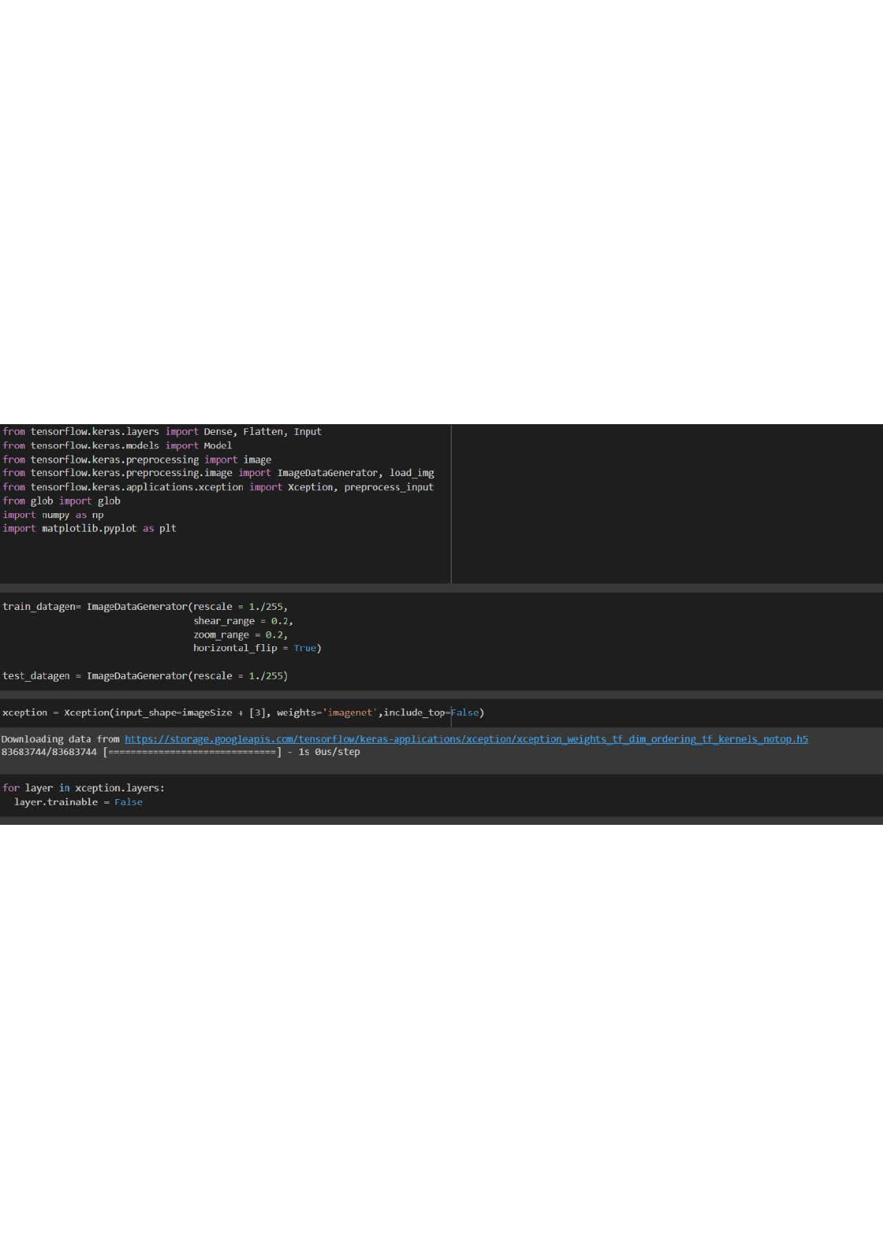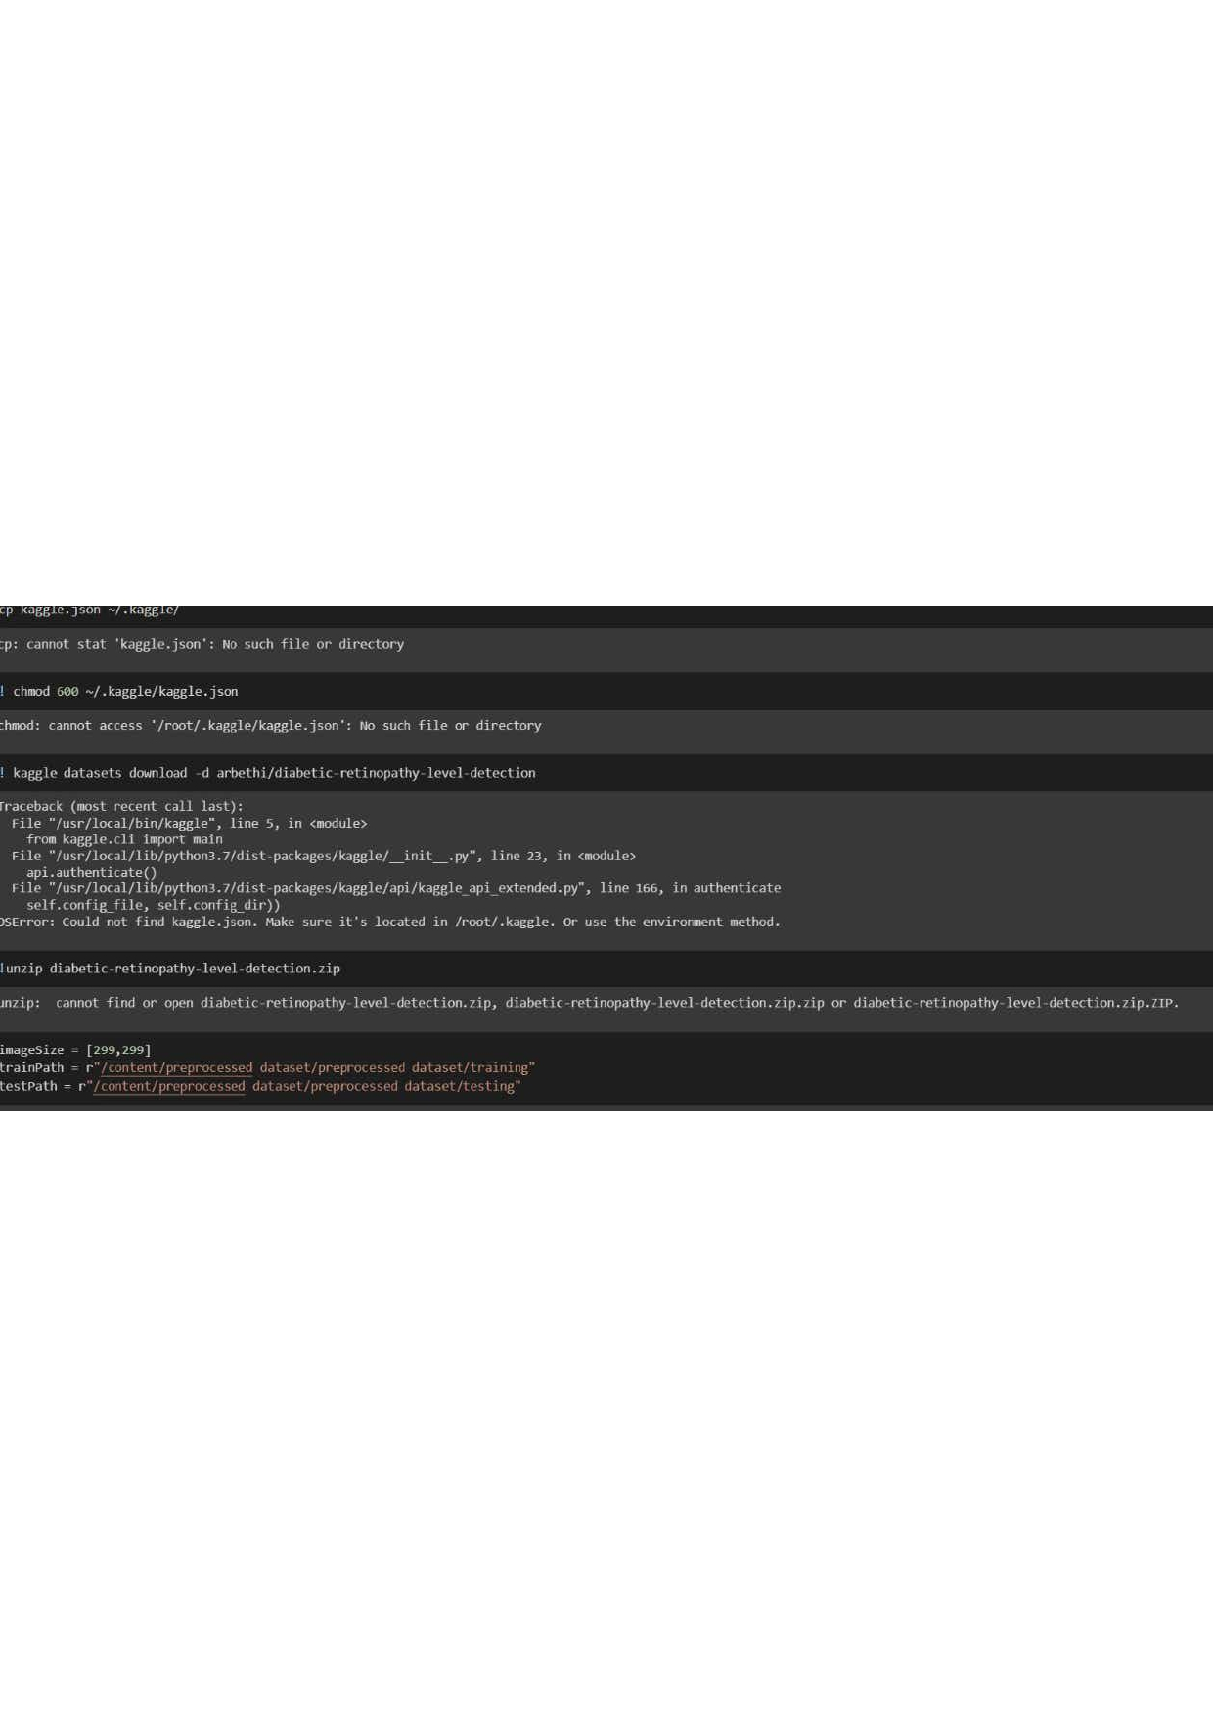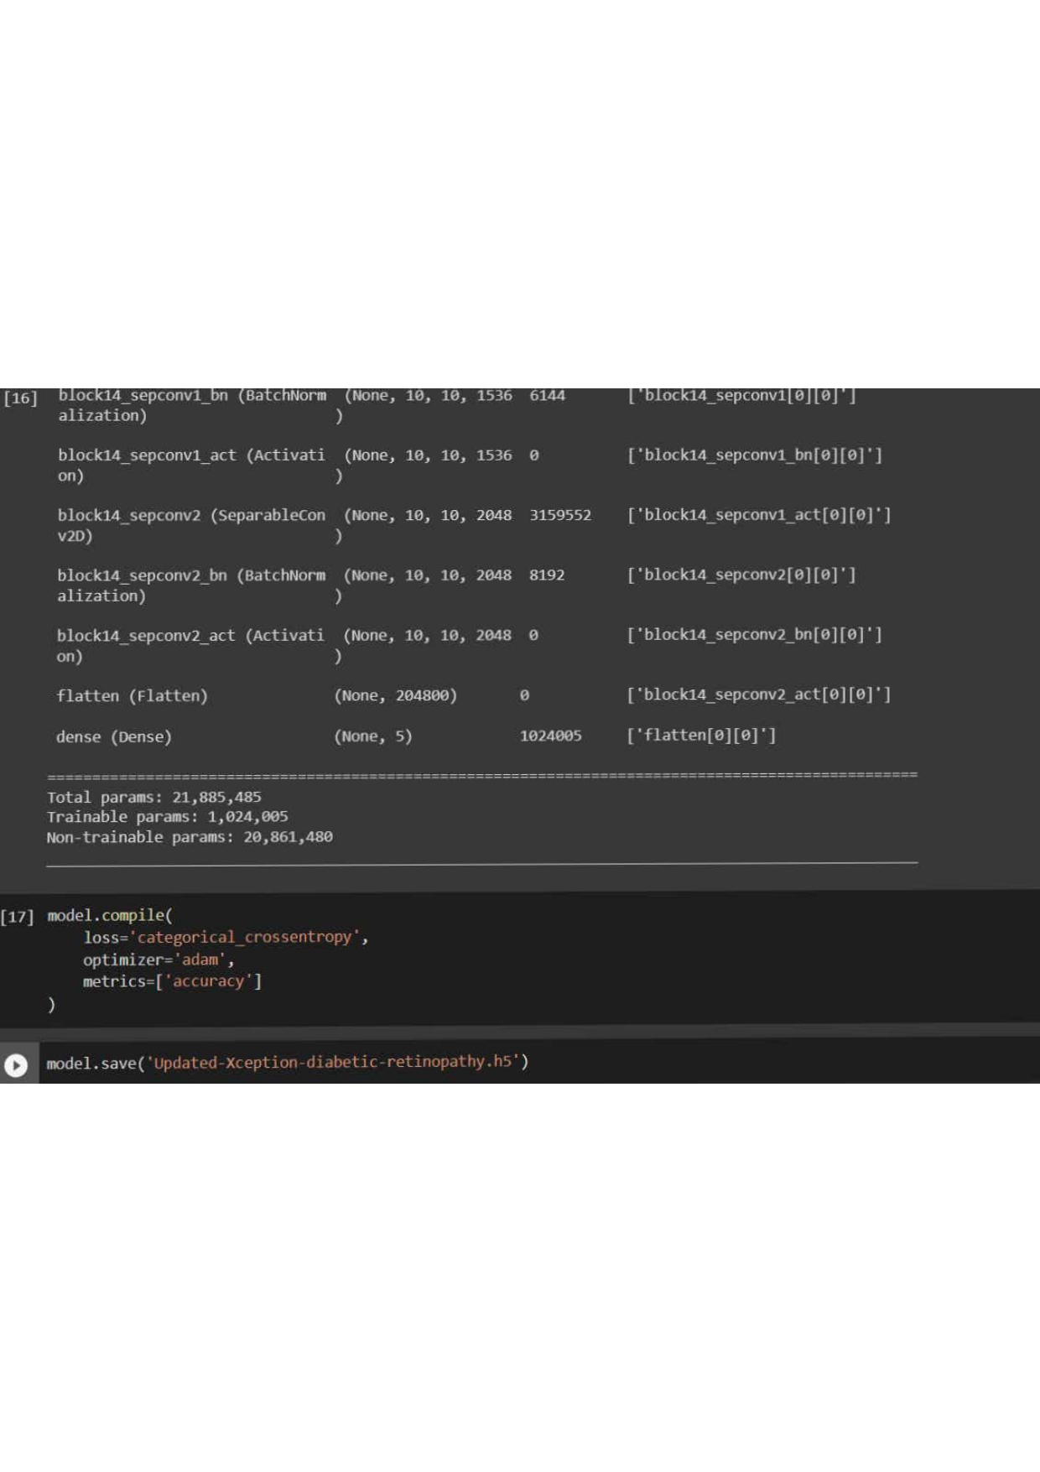

**GITHUB LINK:-** [IBM-Project-12198-1659440400Deep Learning Fundus Image Analysis for Early Detection of Diabetic](https://github.com/IBM-EPBL/IBM-Project-18407-1659684768) [Retinopathy (github.com)](https://github.com/IBM-EPBL/IBM-Project-18407-1659684768)